**Faculty of Computers & Information Technology**

**Blockchain Application for Healthcare**

|  |  |  |  |  |  |  |  |  |  |  |  |  |  |  |  |  |
| --- | --- | --- | --- | --- | --- | --- | --- | --- | --- | --- | --- | --- | --- | --- | --- | --- |
| **Team Members:**   |  |  | | --- | --- | | **ID** | **Name** | | 20-01435 | Yousef Ayman Metry | | 20-00925 | Mark Moheb Mamdouh | | 20-00348 | Maria Aldabea Anis | | 20-01329 | Noran Salah Khalifa | | 20-01171 | Mariam Mina Beshay | | 20-00248 | Amira Zakaria Fahem | | 20-00179 | Aml Samouel Hanaa | |
| **Under the Supervision of:**  **Prof/ Walaa Elsayed**  Professor at The Egyptian E-Learning University  Faculty of Computers and Information Technology  **T.A/ Yousif Ayman** |
| Teaching Assistant at The Egyptian E-Learning University  Faculty of Computers and Information Technology |
|  |
| Table of Contents  [List of Abbreviations](#List_of_Abbreviations)…………..……….………….……………………….…..5  [Acknowledgments.………………….…… …………….…………….…..…....5](#_Toc169016630)  [Abstract………………….……..………………………………………………6](#_Toc169016631)  [1. Introduction……………………………………………………………...... 7](#_Toc169016632)  [2. Blockchain Overview ………………………………………..............7](#_Toc169016633)  [2.1. What is Blockchain? ……………………………………………………7](#_Toc169016634)  [2.2. Types of Blockchain ………………………………………………..…..8](#_Toc169016635)  2.2.1. [Public Blockchain](#Public_Blockchain)  2.2.2. [Private Blockchain](#PrivateBlockchain)  [2.3. Networks………………………………………….....………………….…9](#_Toc169016636)  2.3.1. [Centralized](#Centralized_network)…...9  2.3.1.1.[Structure of Centralized Networks](#Structure_of_Centralized_Networks)  2.3.1.2. [Functionality and Operations](#Functionality_and_Operations)  2.3.2. [Decentralized Networks](#Decentralized_Networks)  2.3.2.1. [Benefits of Decentralized Networks](#Benefits_of_Decentralized_Networks)  2.3.2.2. [Applications of Decentralized Networks](#Applications_of_Decentralized_Networks)  2.3.2.3 [Research Considerations](#Research_Considerations)  2.3.3. [Distributed Networks](#Distributed_Networks)  2.3.3.1. [Key Concepts in Distributed Networks](#Key_oncepts_in_Distributed_Networks)  2.3.3.2. [Types of Distributed Networks](#Types_of_Distributed_Networks)  2.3.3.3. [Applications of Distributed Networks](#Applications_of_Distributed_Networks)  2.3.3.4. [Research status](#Research_status)  [2.4. Three Steps To Creating a Blockchain………………………………..…10](#_Toc169016637)  [2.5. 2.5. The differences between databases and blockchains ? .……….11](#The_differences_between_the_databases_an)  [3. Background …………………………………………………………….…..11](#Background)  [3.1. Blockchain Technology in Healthcare ………………..………………….11](#Blockchain_Technology_in_Healthcare)  [3.2. Problem Statement …………………………………………………….…11](#_Toc169016641)  [3.3. Problem Solution …………………………………………………………11](#_Toc169016642)  [4. Related Work ……………………………………………………................12](#_Toc169016643)  .4.1 Blockchain in Healthcare: A Patient-Centered Model  .4.2 The benefits and threats of blockchain technology in healthcare  .4.3 Blockchain technology applications in healthcare: An overview  .4.4 Analysis of Blockchain in the Healthcare  .4.5 Blockchain Application in Healthcare Systems  [5. Blockchain Frequently Used Terms ………………………....……….……17](#Blockchain_Frequently_Used_Terms)  [5.1. Hash ……………………………………………………………….……..17](#Hash)  5.1.1. [How do Hash Functions work?](#How_do_Hash_Functions_work)  5.1.2. [Types of Hashing](#Types_of_Hashing):  5.1.3. [Applications of Hash Functions](#Applications_of_Hash_Functions):  [5.2. Consensus ……………………………….…..……………………...……18](#Consensus)  5.2.1. [Concept of Consensus](#Concept_of_Consensus)  5.2.2. [Types of consensuses](#Types_of_consensuses)  5.2.3. [Significance of Consensus Mechanisms](#Significance_of_Consensus_Mechanisms)  5.2.4. [Architecture of Consensus Mechanism](#Architecture_of_Consensus_Mechanism)  5.2.5. [Challenges and Future Directions](#Challenges_and_Future_Directions)  [5.3. Public key cryptography …………………………………………..……..20](#Public_key_cryptography)  5.4. [Blockchain concepts](#Blockchain_concepts)  5.4.1. [Smart contract:](#Smart_contract)  5.4.1.1. [Key Features of Smart Contracts](#Key_Features_of_Smart_Contracts)  5.4.1.2. [Applications of Smart Contracts](#Applications_of_Smart_Contracts)  5.4.1.3. [Challenges and Limitations](#Challenges_and_Limitations)  5.4.2. [Nonce](#Nonce):  5.4.2.1. [Types of Nonces](#Types_of_Nonces)  5.4.2.2. [Applications of Nonces](#Applications_of_Nonces)  5.4.2.3. [Challenges](#Challenges)  5.4.3. [ledger](#ledger):  5.4.3.1. [Types of Ledgers](#Types_of_Ledgers)  5.4.3.2[.Importance of Ledgers](#Importance_of_Ledgers)  5.4.3.3. [Limitations and Challenges](#Limitations_and_Challenges)  5.4.4. [Solidity](#Solidity)  5.4.4.1. [Key aspects of solidity include](#Key_aspects_of_solidity_include)  5.4.4.2. [The concept of solidity is important in various fields](#The_concept_of_solidity_is_important_in)  5.4.5. [longest chain rule](#longest_chain_rule):  5.4.5.1. [The Longest Chain Rule works](#The_Longest_Chain_Rule_works)  5.4.5.2. [Importance of the Longest Chain Rule](#Importance_of_the_Longest_Chain_Rule)  5.4.5.3. [Some of the challenges](#Some_of_the_challenges)  [6. Methodology …………………………………………….…………………21](#Methodology)  [6.1. How can Blockchain be used in healthcare? ………..………….……..….21](#How_can_blockchain_be_used_in_healthcare)  [6.2. Blockchain in Healthcare Companies ……………..……………………...22](#blockchain_in_healthcare_companies)  [6.3. Medical Records …………………………………………………………..22](#Medical_Records)  [7. Implementation ……………………………………………………...……...23](#Implementation)  [7.1. Design ………………………………………………………………….…23](#Design)  [7.1.1. PatientFile ………………………………………………………….23](#Patient_File)  [7.1.2. Doctors ………………………….……………………………………25](#Doctors)  [7.1.3. Drugs……………………….………………………………………..27](#Drugs)  [7.1.4. Blocks……………………… ……………………………………….29](#Blocks)  [7.1.5. Add Block. ……………….……………………………………....….31](#Add_Block)  [7.1.6. Edit Blocks. ……………………………………………………….…33](#Edit_Blocks)  [7.1.7. Block Information. ……………………………………………..……35](#Blocks_Information)  [7.2. Back end Blockchain ………………………………………………….35](#Back_end_Blockchain)  [8. Courses ………………………..…………………………………………….43](#Courses)  [9. Technologies Used ……………………………………………………….…44](#Technologies_Used)  [10. Future work ……………………………………………………………..…44](#Future_work)  [11. Conclusion …………………………………………………………........…46](#Conclusion)  [12. References: …………………………………………...….……………..….47](#References)    **List of figures:**  [Figure 1](#Figure_1): Blockchain network …………….................................................................... 9  Figure2: Home pagepage…...…………………………………..………………..23  Figure3: Doctors page  Figure4: Drugs page…………………………………………………………..27  Figure5: Blocks page  Figure6: Add Block page  Figure7: Edit Blocks page…………..………………………………………………..33  Figure8: Blocks Information page…………………………………..……..35  [Figure 9](#Figure_9):………………..……………………………………………….… 35  [Figure 10:](#Figure_10)…………………..………………………………………………36  [Figure 11](#Figure_11):……………………..……………………………………………36  [Figure 12:……………………..……………………………………………](#Figure_12)37  [Figure 13](#Figure_13):……………………………..……………………………………37  [Figure 14:……………………..……………………………………………](#Figure_14)38  [Figure 15:……………………………………………………………..……](#Figure_15)40  [Figure 16](#Figure_16):……………………………………………………………..……40  [Figure 17:……………………………………………………………..……](#Figure_17)41  [Figure 18](#Figure_18):……………………………………………………………..……41  [Figure 19](#Figure_19):…………………………………………………………..………42  [Figure 20](#Figure_20):……………………………………………………………..……43  [Figure 21](#Figure_20):……………………………………………………………..……43  [Figure 22](#Figure_20):……………………………………………………………..……43  [Figure 23](#Figure_20):……………………………………………………………..……43  [Figure 24](#Figure_20):……………………………………………………………..……43  [Figure 25](#Figure_20):……………………………………………………………..……43  [Figure 26](#Figure_20):……………………………………………………………..……43  [Figure 27](#Figure_20):……………………………………………………………..……43  [Figure 28](#Figure_20):……………………………………………………………..……43  [Figure 29](#Figure_20):……………………………………………………………..……43  [Figure 30](#Figure_20):……………………………………………………………..……43  [Figure 31](#Figure_20):……………………………………………………………..……43  [Figure 32](#Figure_20):……………………………………………………………..……43  [Figure 33](#Figure_20):……………………………………………………………..……43  [Figure 34](#Figure_20):……………………………………………………………..……43  [Figure 35](#Figure_20):……………………………………………………………..……43  **List of Abbreviations:**   |  |  | | --- | --- | | Abbreviation | Title | | CME | Continuing Medical Education | | RipeMD | RACE Integrity Primitives Evaluation Message Digest. | | MD5 | Message Digest Algorithm 5 | | SHA-2 | Secure Hash Algorithm 2 | | CRC32 | Cyclic Redundancy Check 32-bit | | HER | Electronic Health Records | | HIPAA | Health Insurance Portability and Accountability Act | | GDPR | General Data Protection Regulation | | JSON | JavaScript Object Notation | | DOM | Document Object Model | | API | Application Programming Interface | | WHO | World Health Organization | | DSCSA | Drug Supply Chain Security Act | | DAO | Decentralized Autonomous Organization | | DEA | Drug Enforcement Administration | | GMP | Good Manufacturing Practices | | CINAHL | Cumulative Index to Nursing and Allied Health Literature | | IEEE | Institute of Electrical and Electronics Engineers | | PRISMA | Preferred Reporting Items for Systematic Reviews and Meta-Analyses |  **Acknowledgments** First, we would like to thank Allah for helping us to complete this project successfully.  We are heartily thankful to Dr. Walaa Elsayed and TA. Yousef Ayman who not only served as our supervisors, but also guided, encouraged and challenged us throughout the project, and guided us with great dedication, never accepting less than our best efforts, and allowing for the completion and success of this project.  We also owe our deepest gratitude to our families for their great support, which without, our work would not have been successful. We also want to thank our TA. Yousef Ayman because it was very helpful to take care of all the details of the project. We also want to thank our older colleagues who helped. We also want to publish Dr. Walaa Elsayed because she helped us with the design of the project. We want to thank our TA. Yousef Ayman for his guidance and inspiring remarks, his support also for his presenting the study and receiving feedback from the research community. We also thank him for sharing his project with us so that we can benefit from it and take it as a reference for us. In the end, we also thank God for granting us success and honoring us. **Abstract** The healthcare industry is increasingly reliant on digital data to provide high-quality patient care. However, the security and integrity of this data are often compromised due to the lack of a robust and decentralized data management system. This paper proposes a blockchain-based solution to address these concerns by creating a secure, transparent, and decentralized platform for managing healthcare data.  The proposed system utilizes blockchain technology to create an immutable and tamper-proof record of patient data, ensuring that all data is accurate, up-to-date, and accessible to authorized healthcare providers. This approach eliminates the risk of data breaches, tampering, or loss, thereby enhancing patient trust and confidence in the healthcare system.  The system also incorporates smart contracts to automate data sharing and access control, ensuring that sensitive patient information is only shared with authorized parties. This not only improves data security but also streamlines the data sharing process, reducing administrative burdens and improving patient care.  Furthermore, the system leverages blockchain's transparency features to provide a clear audit trail of all data transactions, enabling healthcare providers to track the origin, movement, and storage of patient data. This transparency also facilitates compliance with regulatory requirements and improves data quality by identifying and addressing any discrepancies or errors.  The proposed blockchain-based healthcare data management system has the potential to revolutionize the way healthcare data is managed, ensuring that patient data is secure, transparent, and accessible while improving patient care and reducing administrative burdens. **Introduction** Blockchain in Healthcare: A Revolution in Data Security and Management  The healthcare industry is undergoing a digital transformation, driven by the need for improved data security, interoperability, and patient empowerment. In this context, blockchain technology emerges as a potential game-changer.  Blockchain is a distributed ledger technology that creates a secure, transparent, and tamper-proof record of transactions. Essentially, it acts as a shared database, synchronized across multiple computers, where each entry (or "block") is linked to the previous one, creating a chronological chain. This inherent structure offers several advantages for healthcare:   * **Enhanced Data Security:** Blockchain's cryptography makes it extremely difficult to alter or tamper with data. This is crucial for protecting sensitive patient information, such as medical records, from unauthorized access or breaches. * **Improved Data Sharing and Interoperability:** Blockchain can facilitate secure and efficient data sharing between different healthcare providers. Patients can control access to their medical records, granting permission to specific institutions for a defined purpose. This streamlines care coordination and eliminates the need for redundant tests. * **Patient Empowerment:** By placing control over their data in patients' hands, blockchain empowers them to actively participate in their healthcare decisions. They can easily share their medical history with new providers. * **Streamlined Supply Chain Management:** Blockchain can track the movement of pharmaceuticals and medical devices throughout the supply chain, ensuring authenticity and preventing counterfeiting. This promotes patient safety and reduces healthcare costs associated with counterfeit drugs. * **Research Transparency and Efficiency:** Blockchain can be used to securely store and manage clinical trial data. This facilitates collaboration among researchers, accelerating medical advancements. |
|  |

# **2. Blockchain Overview**

## **2.1. What is the Blockchain?**

Blockchain is a distributed ledger with growing lists of records (blocks) that are securely linked together via cryptographic hashes.

Each block contains a cryptographic hash of the previous block, a timestamp, and transaction data Since each block contains information about the previous block.

They effectively make a chain, with each additional block linking to the ones before it.

Blockchains are typically managed by a peer-to-peer (P2P: There is no go-between. The data will not be lost in the text and will be delivered safely) computer network for use as a public distributed ledger, where nodes collectively add to algorithm protocol to make sure of new transaction blocks. Although blockchain records are not unchangeable, since blockchain forks are possible, blockchains may be considered secure by design and consider a distributed computing system.

The implementation of the blockchain within bitcoin made it the first digital currency to solve the double-spending problem (Double spending occurs when someone changes the blockchain network and inserts a private network that allows them to Recovery cryptocurrency) without the need of a trusted authority or central server.

The bitcoin design has inspired other applications and blockchains that are readable by the public and are widely used by cryptocurrencies. The blockchain may be considered a type of payment way. Furthermore, Bitcoin is the first blockchain application and the Genesis Block or Block Zero is the first block in Blockchain. Also, Blockchain makes transfers faster and cheaper, in addition, each block has its own unique hash, so it is not repeated again.

**2.2. Types of Blockchain**:

**2.2.1.** **Public Blockchain (permissionless):**

- A Public Blockchain is a permissionless blockchain.

- Anyone can join the blockchain network, meaning that they can read, write, or participate with a public blockchain.

- Public blockchains are decentralised, no one has control over the network, and they are secure in that the data can’t be changed once validated on the blockchain.

- Examples: Bitcoin and Ethereum.

* **Public Blockchain benefits:**

* Distributed ledger: All nodes in the blockchain participate in the validation of transactions.
* Open reading and writing of data: Any participating can read, write, and view data on the blockchain.
* unchangeable: Once an entry is validated, it cannot be modified or deleted.

**2.2.2.** **Private Blockchain (Permissioned):**

A Private Blockchain is a permissioned blockchain, where it places restrictions on who is allowed to participate in the network and in what transactions.

It can be adopted in the company’s sector where the details need to be shared only between certain nodes.

For example, banks can adopt a private blockchain where financial transaction details are only shared with the concerned partners.

Example: Hyperledger Fabric

* **Private Blockchain benefits:**
* Permissioned blockchain: The banks control the resources and access to the blockchain.
* Improved privacy: The transactions on the blockchain can only be accessed by permissioned partners.
* Increased scalability: companies can add and remove nodes on demand.

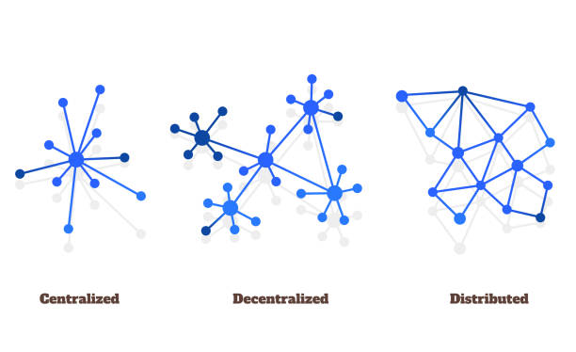**2.3. Networks**

Figure 1: Networks

**2.3.1.** **Centralized network**

Centralized networks are a fundamental architectural paradigm in computer networks and information systems. These networks feature a single central node that holds the authoritative control over the network's operations, data flow, and decision-making processes. This node can be a server, a mainframe, or a central authority. Understanding centralized networks is crucial for grasping their applications, advantages, limitations, and the contexts in which they are most effectively utilized.

**2.3.1.1****. Structure of Centralized Networks:**

In a centralized network, the central node is the core of the network architecture. All peripheral nodes (clients, devices, or terminals) are connected to this central node, which acts as the hub. Communication between peripheral nodes usually passes through the central node. The structure can be visualized as a star topology where the central node is the hub, and all other nodes are spokes.

1. **Central Node**: The central server or mainframe responsible for data processing, storage, and management.
2. **Peripheral Nodes**: The client devices or terminals that connect to the central node to access resources or services.
3. **Communication Channels**: Pathways through which data and instructions are transmitted between the central and peripheral nodes.

**2.3.1.2.** **Functionality and Operations:**

Centralized networks operate through a hierarchical control system where the central node manages network resources, authenticates users, and processes data. Key operations include:

1. **Data Processing**: All data processing tasks are performed at the central node. Peripheral nodes send raw data to the central node for processing and receive processed information.
2. **Resource Allocation**: The central node allocates resources such as bandwidth, storage, and computational power to the peripheral nodes.
3. **Security Management**: Centralized control enables easier implementation of security policies and measures, as all traffic can be monitored and controlled from a single point.
4. **User Authentication and Access Control**: The central node handles user authentication and determines access levels for peripheral nodes.

* **Advantages of Centralized Networks:**

1. **Simplified Management**: With a single point of control, network management, maintenance, and updates are streamlined.
2. **Enhanced Security**: Centralized monitoring and control allow for robust security measures, as all data passes through a single point where it can be inspected and filtered.
3. **Cost Efficiency**: For smaller networks, centralized architectures can be more cost-effective, as they require fewer resources to maintain and operate.
4. **Consistent Data Integrity**: Centralized storage ensures data consistency and integrity since there is a single source of truth.

* **Disadvantages of Centralized Networks:**

1. **Single Point of Failure**: The central node represents a single point of failure. If it goes down, the entire network can become inoperative.
2. **Scalability Issues**: As the number of peripheral nodes increases, the central node can become a bottleneck, leading to performance degradation.
3. **Latency**: Data must travel to and from the central node, which can introduce latency, especially in geographically dispersed networks.
4. **Maintenance and Upkeep**: While management is simplified, the central node requires constant monitoring, maintenance, and updates to ensure reliability and performance.

## **2.3.2.** **Decentralized Networks**

In a world dominated by centralized systems, decentralized networks (DNs) offer a unique and impactful alternative. Unlike traditional networks that rely on a central authority (server) to manage data and interactions, DNs distribute these functionalities across a network of independent devices called nodes. This distribution creates a system that is:

* **Distributed:** There's no single point of failure. Workloads and data are spread across numerous devices, making the network more resilient.
* **Autonomous:** Nodes operate independently, following a set of protocols for communication and collaboration. This reduces reliance on a central entity for control.
* **Transparent:** Transactions and data storage are often publicly verifiable, fostering trust and immutability within the network.
* **Here's a deeper dive into how DNs function:**
* **Network Structure:** DNs consist of interconnected nodes, each acting as a mini-server. These nodes can be computers, servers, or even specialized hardware.
* **Communication Protocols:** Nodes communicate with each other using pre-defined protocols. These protocols establish rules for data exchange, security, and consensus mechanisms (how nodes agree on the state of the network).
* **Consensus Mechanisms:** Since there's no central authority, DNs employ consensus mechanisms to ensure all nodes agree on the validity of transactions and data stored on the network. Common mechanisms include Proof of Work (PoW) and Proof of Stake (PoS).

**2.3.2.1****. Benefits of Decentralized Networks:**

* **Enhanced Security:** The lack of a central point of attack makes DNs more resistant to hacks and outages.
* **Increased Reliability:** Distributed storage and processing ensure the network remains functional even if some nodes go offline.
* **Transparency and Trust:** Public verifiability fosters trust among participants as they can independently validate transactions and data integrity.
* **Censorship Resistance:** The absence of a central authority makes it difficult to censor information or block transactions on the network.

**2.3.2.2.** **Applications of Decentralized Networks:**

* **Blockchain Technology:** The foundation for cryptocurrencies like Bitcoin, blockchains leverage DNs to create a secure and transparent ledger of transactions.
* **File Sharing:** Decentralized file storage platforms like IPFS eliminate the need for centralized servers, empowering users to control their data.
* **Decentralized Applications (dApps):** DNs enable the development of applications that operate autonomously, independent of any central control.

**2.3.2.3** **Research Considerations:**

* **Scalability:** How can DNs efficiently handle increasing network traffic and data storage requirements?
* **Security:** While DNs offer some security benefits, they are not immune to vulnerabilities. How can these vulnerabilities be addressed?
* **Regulation:** The decentralized nature of DNs poses challenges for traditional regulatory frameworks. How can regulations be adapted to this new paradigm?

By understanding the core principles, benefits, and applications of decentralized networks, your research paper can effectively explore this transformative technology and its potential impact on various industries and aspects of our digital world.

## **2.3.3.** **Distributed Networks**

Distributed networks represent a fundamental structure for enabling communication and resource sharing across geographically dispersed systems. Unlike centralized networks with a single point of control, distributed networks distribute tasks, data, and processing power among multiple interconnected devices or nodes. This distribution offers several advantages:

* **Scalability:** Distributed networks can easily expand by adding more nodes, allowing them to handle increasing workloads and data demands.
* **Resilience:** The absence of a central point of failure makes them more resistant to outages. If one node goes down, others can pick up the slack, ensuring continued network operation.
* **Parallel Processing:** By distributing tasks across multiple nodes, distributed networks can achieve faster processing speeds compared to centralized systems.

**2.3.3.1.** **Key Concepts in Distributed Networks:**

* **Nodes:** These are the individual devices (computers, servers, etc.) that participate in the network. They communicate and collaborate to achieve shared goals.
* **Communication Protocols:** Nodes rely on pre-defined protocols for communication. These protocols establish rules for data exchange, synchronization, and security measures.
* **Resource Sharing:** Distributed networks allow for efficient resource sharing. Nodes can share storage space, processing power, and other resources with each other.
* **Distributed Computing:** Complex tasks are broken down into smaller subtasks and distributed among different nodes for parallel processing. The results are then aggregated to achieve the final outcome.

**2.3.3.2** **Types of Distributed Networks:**

* **Client-Server Networks:** While not purely distributed, client-server networks distribute tasks between clients (user devices) and servers. Servers provide resources and perform computations, while clients make requests and utilize the results.
* **Peer-to-Peer (P2P) Networks:** These networks consist of interconnected nodes with equal capabilities, eliminating the need for dedicated servers. Nodes directly communicate and share resources with each other.
* **Cluster Computing:** A cluster is a collection of interconnected computers working together as a single entity. They share resources and processing power to handle large-scale computations.

**2.3.3.3** **Applications of Distributed Networks:**

* **High-Performance Computing (HPC):** Distributed networks are crucial for HPC applications that require immense processing power for scientific simulations and data analysis.
* **Content Delivery Networks (CDNs):** CDNs leverage distributed networks to provide geographically dispersed servers for faster content delivery to users.
* **Cloud Computing:** Cloud computing platforms rely on distributed networks to provide on-demand access to computing resources like storage, servers, and databases.

**2.3.3.4** **Research status:**

* **Security:** Maintaining data security and ensuring privacy in distributed networks can be challenging. Research on secure communication protocols and access control mechanisms is essential.
* **Load Balancing:** Efficiently distributing workload across nodes to prevent bottlenecks and optimize network performance is an ongoing research area.
* **Fault Tolerance:** Mechanisms to detect and recover from node failures without compromising system functionality are crucial for ensuring network reliability.

By exploring these aspects of distributed networks, your research paper can delve into the intricacies of this foundational technology and its role in shaping the landscape of modern computing and communication.

**2.4. Steps of Creating a Blockchain**

Blockchain technology is a decentralized digital ledger that records transactions across multiple computers securely and transparently. Creating a blockchain involves several critical steps, from conceptualization to implementation. This guide provides a detailed examination of each step involved in creating a blockchain, emphasizing the technical and practical aspects.

**Note:** Genesis Block or Block Zero is the first block in Blockchain.

* **Step 1: Identify a Problem to Solve:**

**1. Define the Problem Statement**: Clearly outline the challenges you are trying to solve with the blockchain solution. Ensure that the problem is specific and well-defined.

**2. Compare to Blockchain Use Cases:** Compare your problem to the high-level use cases of blockchain development to determine if a blockchain solution is actually capable of solving the issues.

* **Step 2: Draft Your Business Requirements:**

1. **Develop a Business Requirements Document:** Create a detailed document

outlining the business needs and objectives for the blockchain application.

**2. Consider Technologies:** Identify the technologies needed both on-chain and off chain for a complete ecosystem. Use these details to create a more tangible product roadmap.

* **Step 3: Identify a Consensus Mechanism:**

**1. Choose a Consensus Algorithm:** Select a consensus algorithm that best fits your business needs and objectives. Popular consensus mechanisms include:

* **Proof of Work (PoW):** Used in Bitcoin and other cryptocurrencies.
* **Proof of Stake (PoS):** Used in Ethereum and other cryptocurrencies.
* **Byzantine Fault Tolerant (BFT):** Used in various blockchain platforms.
* **Deposit-Based Consensus:** Used in some blockchain platforms.
* **Proof of Elapsed Time:** Used in some blockchain platforms.

* **Step 4: Choose a Blockchain Platform:**

**1. Select a Blockchain Platform:** Choose a blockchain platform that aligns with your business needs and objectives. Consider factors such as:

* **Permissioned or Permission less:** Determine whether you need a private, public, or hybrid blockchain network.
* **Programming Languages:** Choose the programming languages for your blockchain application.
* **Operating System:** Determine the operating system for your application.

* **Step 5: Develop the Blockchain Solution:**

Develop the Blockchain Application: Use the chosen blockchain platform and consensus mechanism to develop the blockchain application.

Implement Smart Contracts: Implement smart contracts to automate specific actions and ensure the integrity of the blockchain.

* **Step 6: Test and Validate the Blockchain:**

1. **Conduct Unit Testing:** Test individual components of the blockchain application to ensure they function correctly.
2. **Conduct Integration Testing:** Test the integration of different components to ensure they work together correctly.
3. **Conduct Performance Testing:** Test the performance of the blockchain application to ensure it can handle a large volume of transactions.
4. **Conduct Security Testing:** Test the security of the blockchain application to ensure it is secure against various types of attacks.

* **Step 7: Deploy and Maintain the Blockchain:**

1. **Deploy the Blockchain:** Deploy the blockchain application to the chosen environment (cloud, on-premises, or both).
2. **Monitor and Maintain:** Monitor the blockchain application for any issues or anomalies and perform regular maintenance to ensure optimal performance and security.

* **Step 8: Integrate with Other Systems:**

1. **Integrate with Existing Systems:** Integrate the blockchain application with existing systems and data infrastructure using APIs or middleware solutions.
2. **Ensure Data Formatting and Standardization:** Ensure that data is consistently interpreted across all systems by standardizing data formats.

**2.5.** **The differences between the databases and the blockchain****s**

Databases and blockchains are both systems for storing and managing data, but they are fundamentally different in terms of structure, functionality, and use cases. Below is a detailed comparison highlighting the key differences between the two:

* 1. **Data Structure:**
* **Database:** Traditional databases use various structures to store data, such as tables (in relational databases) or documents (in NoSQL databases). Data can be updated, deleted, or inserted in any part of the database.
* **Blockchain:** A blockchain is a sequential chain of blocks, each containing a set of transactions. Each block is linked to the previous one through a cryptographic hash, forming an immutable chain. Once data is written to a block and the block is added to the chain, it cannot be altered or deleted.
  1. **Centralization vs Decentralization:**

* **Databases**: Centralized systems where data is stored on a single server, managed by an administrator, and accessible only through a network.
* **Blockchains**: Decentralized systems where data is distributed across a network of nodes, ensuring that no single entity controls the data.
  1. **Security:**
* **Databases**: Data can be secured through passwords and other measures, but they are still vulnerable to attacks and data breaches.
* **Blockchains**: Data is tamper-proof due to the use of cryptography and the decentralized nature of the system, making it resistant to tampering and data breaches.

**4. Data Modification:**

* **Databases**: Data can be modified by the administrator, and changes can be made to the data structure.
* **Blockchains**: Data cannot be modified once it is added to the blockchain, ensuring the integrity of the data.

1. **Data Storage:**

* **Databases**: Data is stored in a structured schema, making it easy to search and retrieve.
* **Blockchains**: Data is stored in blocks, which are linked together using cryptography, ensuring that each block contains the hashed information from the previous block.

**6. Data Access:**

* **Databases**: Data is accessible only through the network and requires permission from the administrator.
* **Blockchains**: Data is accessible to all nodes on the network, and modifications do not require permission.

**7. Data History:**

* **Databases**: Centralized databases typically store only the current information.
* **Blockchains**: Blockchains store both current and historical data, providing a complete record of all transactions.

**8. Performance:**

* **Databases**: Centralized databases are generally faster and more efficient for large datasets.
* **Blockchains**: Decentralized blockchains can be slower due to the need for consensus among nodes, but they are more secure.

**9. Data Ownership:**

* **Databases**: Data ownership is centralized, and the administrator has control over the data.
* **Blockchains**: Data ownership is decentralized, and all nodes on the network have a copy of the data, ensuring that no single entity controls the data.

**3.** **Background**

**3.1** **Blockchain Technology in Healthcare**

Blockchain technology has been increasingly recognized for its potential to transform various industries, including healthcare. This document provides an in-depth exploration of the utilization of blockchain in healthcare applications, highlighting the benefits, challenges, use cases, security considerations, regulatory aspects, and future prospects.

**3.2 problem statement**

The project talks about how to keep the patient’s medical history, which consists of blood type, tests, x-rays, chronic diseases such as diabetes and high blood pressure, medicine and everything related to the patient’s medical history.

In some cases when the patient is unconscious or visits a new doctor the treating doctor can give the patient the correct medicine for his condition.

So blockchain makes it easier for the doctor to know everything about the patient.

**3.3 problem solution**

In the healthcare sector, blockchain technology offers several solutions to address various challenges:

1. **Data Security and Privacy:** Blockchain provides a secure and immutable way to store and share sensitive medical data, ensuring patient privacy and preventing unauthorized access.

**2. Interoperability:** Blockchain can facilitate interoperability by creating a decentralized system where different healthcare providers can securely share patient data acrossdisparatesystems, improving care coordination and reducing medical errors.

**3. Supply Chain Management:** Blockchain enables transparent and traceable supply chain management for pharmaceuticals, medical devices, and other healthcare products, reducing the risk of counterfeit drugs and ensuring the integrity of the supply chain.

**4. Patient Empowerment:** Through blockchain-based solutions, patients can have greater control over their medical records, granting or revoking access to healthcare providers as needed, leading to more patient-centered care.

**5. Clinical Trials and Research:** Blockchain can streamline the process of conducting clinical trials by securely recording and verifying trial data, ensuring data integrity and transparency,

which can accelerate the development of new treatments and therapies.

**6. Healthcare Payments and Billing:** Blockchain can automate and streamline healthcare payments and billing processes, reducing administrative costs and improving efficiency while minimizing billing errors and fraud.

**7. Credentialing and Licensing:** Blockchain can be used to verify and manage healthcare provider credentials and licenses, ensuring that only qualified professionals have access to patient data and services.

By leveraging blockchain technology, healthcare organizations can enhance data security, interoperability, transparency, and efficiency across various aspects of the healthcare ecosystem.

**4.** **Related Work**

We have searched about the related works about the blockchain that are related to pur project, so we found 14 research on blockchain in the field of healthcare, and after completing the research, we chose the best our project's related research.

* 1. **Blockchain in Healthcare: A Patient-Centered Model**[3]
* **Year: Published online 2019 Aug 8.**

Each block in the chain is both its own independent unit containing its own information, and a dependent link in the collective chain, and this duality creates a network regulated by participants who store and share the information, rather than a third party. Blockchain has many applications in healthcare, and can improve mobile health applications, monitoring devices, sharing and storing of electronic medical records, clinical trial data, and insurance information storage. Research about blockchain and healthcare is currently limited, but blockchain is on the brink of transforming the healthcare system; through its decentralized principles, blockchain can improve accessibility and security of patient information, and can therefore overturn the healthcare hierarchy and build a new system in which patients manage their own care.

* **Results of this research:**

The research "Blockchain in Healthcare: A Patient-Centered Model" highlights several key findings, including:

Enhanced Privacy and Security: Using distributed ledger technology to improve the protection of patients' data and ensure the confidentiality of their information.

Facilitated Data Exchange: Streamlining data sharing processes among different healthcare entities, leading to increased efficiency in healthcare delivery.

Improved Transparency: Increasing transparency within the healthcare system, aiding in enhancing the quality of healthcare services and patient experience.

Enhanced Verification and Authentication: Ensuring the accuracy and reliability of health data, thereby reducing medical errors and improving health outcomes.

* 1. **The benefits and threats of blockchain technology in healthcare:**
* **Year: Published online 2020**.
* **Background**

The application of blockchain technology is being explored to improve the interoperability of patient health information

between healthcare organizations while maintaining the privacy and security of data.

* **Objectives**

The objective of this scoping review is to explore and categories the benefits and threats of blockchain technology application in a healthcare system.

* **Methods**

Databases such as PubMed, CINAHL, IEEE, Springer, and ScienceDirect were searched using a combination of terms related to blockchain, healthcare, benefits and threats. Backward-reference list checking was conducted to identify other relevant references. Study selection process was performed in three steps based on PRISMA flow diagram. Extracted data were synthesized and presented narratively using tables and figures.

* **Results**

The search resulted in 84 relevant studies that have been conducted of which only 37 unique studies were included in this review. Eight benefits of blockchain were categorizeded either patient related-benefits (security and authorization, personalized healthcare, patients’ health data tracking, and patient’s health status monitoring) or organizational-related benefits (health information exchange, pharmaceutical supply chain, clinicaltrials, and medical insurance management). Meanwhile, eight threats of blockchain were categorized into three groups: organizational threats (installation and transaction costs, interoperability issues, and lack of technical skills), social threats (social acceptance and regulations issues), and technological threats (scalability issues, authorization and security issues, high energy consumption, and slow processing speeds).

**4.3. Blockchain technology applications in healthcare: An overview**

* **Year Published:20 September 2021.**

[Blockchain](https://www.sciencedirect.com/topics/computer-science/blockchain) is an emerging technology being applied for creating innovative solutions in various sectors, including healthcare. A Blockchain network is used in the healthcare system to preserve and exchange patient data through hospitals, diagnostic laboratories, pharmacy firms, and physicians. Blockchain applications can accurately identify severe mistakes and even dangerous ones in the medical field. Thus, it can improve the performance, security, and transparency of sharing medical data in the health care system. This technology is helpful to medical institutions to gain insight and enhance the analysis of medical records. In this paper, we studied Blockchain technology and its significant benefits in healthcare. Various Capabilities, Enablers, and Unified Work-Flow Process of Blockchain Technology to support healthcare globally are discussed diagrammatically. Finally, the paper identifies and debates

fourteen significant applications of Blockchain for healthcare. Blockchain plays a decisive part in handling deception in clinical trials; here, the potential of this technology offer is to improve data efficiency for healthcare. It can help avoid the fear of data manipulation in healthcare and supports a unique data storage pattern at the highest level of security. It provides versatility, interconnection, accountability, and [authentication](https://www.sciencedirect.com/topics/computer-science/authentication) for data access. For different purposes, health records must be kept safe and confidential. Blockchain helps for the decentralized protection of data in healthcare and avoids specific threats.

Blockchain is a [distributed ledger](https://www.sciencedirect.com/topics/computer-science/distributed-ledger) network that adds and never deletes or modifies records without a [common consensus](https://www.sciencedirect.com/topics/computer-science/common-consensus). A Blockchain hash’s value depends on a [cryptographic hash](https://www.sciencedirect.com/topics/computer-science/cryptographic-hash) that connects newly added information block records with each data block. The distributed Blockchain ledger architecture ensures that data is not processed in any centralized venue, making it accessible and accountable to all network users. This decentralized system avoids a single attack, strengthening and securing the system. It facilitates better control of health records and patient care by minimizing twice the amount of medical practice and monitoring, saving both practitioners and patients time and resources. The patient will watch where their information goes and achieve it by keeping health records on a blockchain.

* **Results of this research:**

Enhanced Security and Privacy:

1. Blockchain technology provides a reliable and secure solution for exchanging healthcare data, helping to protect patient privacy and sensitive information.

2. Streamlined Administrative Processes: Blockchain can improve the efficiency of managing electronic medical records and simplify the sharing and access of medical information.

3. Increased Transparency and Accountability: Blockchain enables transparent and trustworthy tracking of medical data history, enhancing accountability and trust within the healthcare system.

4. Improved Management of Medical Data: The technology can be utilized to enhance the management and secure updating of medical data, contributing to improved healthcare quality and patient experience.

The emergence of blockchain technology makes it possible to address distributed system security.

**4.4. Analysis of Blockchain in the Healthcare**

Sector: Application and Issues

Year Published: 23 August 2022

A key factor of this ability is the decentralization of the symmetrically distributed ledgers of blockchain.

Such decentralization has replaced several security functionalities of centralized authority with the use of cryptographic systems.

That is, public or asymmetric cryptography is the key part of what makes blockchain technology possible.

Recently, the blockchain experience introduces the chance for the healthcare field to implement these knowhows in their electronic records.

This adoption supports retaining and sharing the symmetrical patient records with the appropriate alliance of hospitals and healthcare providers in a secure decentralized system, using asymmetric cryptography like hashing, digitally signed transactions, and public key infrastructure.

These include specialized applications for drug tracking, applications for observing patients, or Electronic Health Records (EHR).

In this work, we provide a thorough review of the issues and applications of utilizing blockchain in the healthcare and medical fields focusing the particular challenges and aspects.

Specifically, this paper aims to investigate how blockchain technology can be applied to improve the overall performance of the healthcare sector and to explore the various challenges and concerns of the application of blockchain in the healthcare system.

* **Results of this research:**

Research on blockchain in the healthcare sector has yielded several key findings and benefits:

1. Improved data transport and secure sharing: Blockchain can provide a secure and encrypted platform for exchanging medical data between healthcare providers and patients without compromising privacy.

2. Drug tracking and supply chain management: Blockchain technology can enhance drug tracking across the supply chain, reducing drug counterfeiting and increasing their reliability.

3. Enhanced medical record management: Blockchain can improve the accuracy and security of patient records, reducing errors and facilitating access to vital medical information when needed.

However, applications of blockchain in healthcare also face challenges such as privacy and security concerns, implementation costs, and regulatory adoption.

**4.5. Blockchain Application in Healthcare Systems**

Year Published: 8 January 2023

In the recent years, blockchain technology has gained significant attention in the healthcare sector. It has the potential to alleviate a wide variety of major difficulties in electronic health record systems. This study presents an elaborate overview of the existing research works on blockchain applications in the healthcare industry. This paper evaluates 144 articles that discuss the importance and limits of using blockchain technologies to improve healthcare operations. The objective is to demonstrate the technology’s potential uses and highlight the difficulties and possible sectors for future blockchain research in the healthcare domain. The paper starts with an extensive background study of blockchain and its features. Then, the paper focuses on providing an extensive literature review of the selected articles to highlight the current research themes in blockchain-based healthcare systems. After that, major application areas along with the solutions provided by blockchain in healthcare systems are pointed out. Finally, a discussion section provides insight into the limitations, challenges and future research directions.

* **Results of this research:**

The key findings of research on blockchain application in healthcare systems, and the benefits derived from it, include:

Enhanced transparency and trust:

1. Blockchain can increase transparency and trust in healthcare systems by securely recording data in an immutable manner.

2. Streamlined administrative processes: Blockchain technology can simplify administrative processes in hospitals and medical institutions by effectively and securely managing medical records and health information.

3. Improved access to medical data: Blockchain can provide easy and secure access to medical records for patients and healthcare providers, facilitating information exchange and improving the quality of care.

4. Enhanced security and privacy: Blockchain can enhance the security of healthcare data and protect it from tampering or breaches, while also safeguarding patients' privacy and the integrity of their sensitive information. These findings demonstrate that the application of blockchain technology in the healthcare sector can lead to significant improvements in efficiency and quality of healthcare delivery.

**5.** **Blockchain Frequently Used Terms**

**5.1.** **Hash**

A hash function is a mathematical function that takes an input string of any length and converts it to a fixed-length output string. The fixed-length output is known as the hash value. To be cryptographically secure and useful, a hash function should have the following properties:

1-Collision resistant.

2-Preimage resistance.

3-Second preimage resistance.

4-Large output space.

5-Deterministic.

6-Avalanche Effect.

7-Puzzle Friendliness.

8-Fixed-length Mapping

**5.1.1.** **How do Hash Functions work?**

The hash function takes the input of variable lengths and returns outputs of fixed lengths. In cryptographic hash functions, the transactions are taken as inputs and the hash algorithm gives an output of a fixed size.

**5.1.2.** **Types of Hashing:**

There are many different types of hash algorithms such as RipeMD, Tiger, xxhash and more, but the most common type of hashing used for file integrity checks are MD5, SHA-2 and CRC32.

Uses of Hash Functions in Blockchain:

The blockchain has a number of different uses for hash functions. Some of the most common uses of the hash function in blockchain are:

1. Merkle Tree.

2. Proof of Work Consensus.

3. Digital signatures.

4. The chain of blocks

**5.1.3.** **Applications of Hash Functions:**

* **Data Integrity:** Hash functions are used to ensure the integrity of data by generating a checksum.
* **Digital Signatures:** Hash functions are used to create digital signatures that can be used to verify the authenticity of a message.
* **Password Storage:** Hash functions are used to store passwords securely by hashing them and storing the hash value.
* **Data Retrieval:** Hash functions are used to efficiently retrieve data from a database by using the hash value as an index.

**5.2.** **Consensus**

Consensus mechanisms are a crucial component of blockchain technology, ensuring that all nodes on a network agree on the current state of the network and the authenticity of transactions. This agreement is vital for preserving the security and integrity of the blockchain. In this paper, we will explore the concept of consensus, its significance in blockchain technology, and the various consensus mechanisms used in different blockchain platforms.

**5.2.1.** **Concept of Consensus**

Consensus is the process of reaching agreement among a group of people or entities on a specific decision or action. In the context of blockchain technology, consensus is used to guarantee that all nodes on the network agree on the current state of the network and the authenticity of transactions. This is achieved through various consensus mechanisms, which are designed to ensure that the network operates in a decentralized and secure manner.

**5.2.2.** **Types of consensuses**

**1-Proof of Work (POW): -**

Proof of Work (POW) is a consensus algorithm widely used in blockchain, notably in Bitcoin. Miners compete to solve complex mathematical problems, involving hashing or encryption, requiring substantial computational power. The algorithm ensures that only valid transactions are added to the blockchain by making it computationally difficult for miners. Successful miners are rewarded with cryptocurrency. POW enhances security by making it impractical for malicious actors to alter transactions, ensuring the integrity of the blockchain.

**2-Proof of Stake (POS): -**

Proof of Stake consensus algorithm replaces the POW mining with a mechanism where blocks are validated according to the stake of the participants. The validator of each block (also called forger or minter) is determined by an investment of the cryptocurrency itself and not by the amount of computational power allocated.

Each POS system may implement the algorithm in different ways, but in general, the blockchain is secured by a pseudo-random election process that considers the node's wealth and the coins age (how long the coins are being locked or staked) - along with a randomization factor.

**3-Proof of authority: -**

Proof of authority It is always used in private blockchain This means that I am the only people who are authorized to work in the Transaction Training Validation. They are the only ones who work in the Transaction Training Validation, so I will not be required to have any computational power such as a proof of work or a stack or money or anything else. Rather, you are required to have a permit to work in the Training Training and to take your block on the basis that it is valid.

**4-Proof of Capacity (POC): -**

Proof of Capacity algorithm focuses on determining the storage capacity available for validation. If my device has low computational power, my priority will be low. In essence, it assesses how much workload or capacity my machines can handle and distributes it equally based on my machine's capacity.

**5-Proof of Elapsed Time (POET):-**

The "Proof Elapsed Time " consensus mechanism takes into consideration the time factor. This means that it requires a certain amount of time for validation to occur. The distribution of nodes on the validation is done equally based on time.

In other words, the validation process allocates nodes evenly according to the elapsed time.

**5.2.3.** **Significance of Consensus Mechanisms**

Consensus mechanisms have become indispensable components of distributed ledgers, databases, and blockchains. They play a vital role in securing information by utilizing automated group verification. Consensus mechanisms facilitate agreement, trust, and security across a decentralized computer network, ensuring that the network operates in a decentralized and secure manner.

**5.2.4.** **Architecture of Consensus Mechanism**

The architecture of consensus mechanisms involves several key components, including:

Block Header: This is the first item that is accumulated in a block and contains several important pieces of information, including the reference to the previous block, the timestamp, and the hash code.

Block Body: This contains the transactions that are included in the block.

Consensus Algorithm: This is the mechanism used to ensure that all nodes on the network agree on the current state of the network and the authenticity of transactions.

**5.2.5.**  **Challenges and Future Directions**

Despite the significance of consensus mechanisms in blockchain technology, there are several challenges and future directions that need to be addressed. These include:

Scalability: Consensus mechanisms need to be scalable to handle large volumes of transactions.

Security: Consensus mechanisms need to be secure to prevent attacks and ensure the integrity of the network.

Interoperability: Consensus mechanisms need to be interoperable to enable different blockchain platforms to communicate and share data.

**5.3** **Public key cryptography**

Public key cryptography is a security feature to uniquely identify participants in the blockchain network. This mechanism generates two sets of keys for network members.

One key is a public key that is common to everyone in the network.

The other is a private key that is unique to every member. The private and public keys work together to unlock the data in the ledger

* **Public Key:**

Public keys are designed to be public. They can be freely given to everyone or posted on the internet.

By using the public key, one can encrypt the plain text message into the cipher text.

It is also used to verify the sender authentication. In simple words, one can say that a public key is used for closing the lock.

* **Private Key:**

The private key is totally opposite of the public key.

The private key is always kept secret and never shared.

Using this key, we decrypt cipher text messages into plain text. In simple words, one can say that the private key is used for opening the lock.

* **Public key cryptography example**

For example, John and

Jill are two members of the network. John records a transaction that is encrypted with his private key. Jill can decrypt it with her public key. This way, Jill is confident that John made the transaction. Jill's public key wouldn't have worked if John's private key had been tampered with.

**5.4.** **Blockchain concepts**

**5.4.1.** **Smart contract:**

A smart contract is a computer program that runs on a blockchain network. It is designed to automatically execute predefined actions when certain conditions are met. These conditions are encoded into the contract's code, and once the conditions are verified, the contract will self-execute the corresponding actions, such as transferring funds, updating records, or triggering a specific event.

**5.4.1.1.** **Key Features of Smart Contracts**

* **Automation:** Smart contracts eliminate the need for manual intervention, as they automatically execute the terms of an agreement once the predetermined conditions are met.
* **Transparency**: The code of a smart contract is visible to all parties involved, ensuring transparency and reducing the risk of disputes.
* **Immutability**: Smart contracts are stored on a blockchain, which is a decentralized and tamper-resistant ledger, making it difficult to alter the terms of the contract once it is deployed.
* **Trustless Execution:** Smart contracts do not require a trusted intermediary to facilitate the transaction, as the code itself ensures the execution of the agreement.

**5.4.1.2.** **Applications of Smart Contracts**

Smart contracts have a wide range of applications across various industries, including:

* **Financial Services:** Smart contracts can be used for automated loan processing, insurance claims, and the execution of complex financial instruments.
* **Supply Chain Management:** Smart contracts can be used to track the movement of goods, automate payments, and ensure the integrity of supply chain data.
* **Real Estate:** Smart contracts can be used to facilitate property transactions, automate rental payments, and manage property ownership records.
* **Healthcare:** Smart contracts can be used to securely store and share patient data, automate insurance claims, and manage clinical trials.

**5.4.1.3.** **Challenges and Limitations**

While smart contracts offer numerous benefits, they also face some challenges and limitations:

* **Legal Uncertainty:** The legal status of smart contracts is still evolving, and there are questions about their enforceability and integration with traditional legal frameworks.
* **Security Vulnerabilities:** Smart contracts can be vulnerable to security breaches and bugs in their code, which can lead to unintended consequences or financial losses.
* **Scalability:** Blockchain networks, which are the foundation for many smart contract platforms, can face scalability issues, leading to slow transaction times and high fees.
* **Complexity:** Developing and deploying complex smart contracts can be a challenging and time-consuming process, requiring specialized technical expertise.

**5.4.2.** **Nonce**:

A nonce is a random value used once in a specific context, typically in a cryptographic protocol. It is used to prevent replay attacks, where an attacker attempts to reuse a previously sent message to gain unauthorized access or manipulate the communication. Nonces are essential in ensuring the authenticity and integrity of digital communications.

**5.4.2.1.** **Types of Nonces**

There are two primary types of nonces:

* **Session Nonce:** A session nonce is used to identify a specific session or connection between two parties. It is typically generated randomly and used once during the session.
* **Message Nonce:** A message nonce is used to identify a specific message or packet. It is typically generated randomly and used once for that specific message.

**5.4.2.2.** **Applications of Nonces**

Nonces are used in various cryptographic protocols to ensure the security and integrity of digital communications. Some of the key applications include:

* **Secure Sockets Layer (SSL):** SSL uses nonces to prevent replay attacks and ensure the authenticity of communication.
* **Transport Layer Security (TLS):** TLS uses nonces to prevent replay attacks and ensure the authenticity of communication.
* **Public Key Cryptography:** Nonces are used in public key cryptography to ensure the authenticity and integrity of digital signatures.
* **Digital Signatures:** Nonces are used in digital signatures to prevent replay attacks and ensure the authenticity of the signature.
  + - 1. **Challenges**

While nonces are essential in ensuring the security and integrity of digital communications, they also pose some challenges and limitations:

* **Random Number Generation:** Generating truly random nonces can be challenging, especially in resource-constrained environments.
* **Nonce Reuse:** Reusing a nonce can compromise the security of the communication, making it vulnerable to replay attacks.
* **Nonce Prediction:** Predicting a nonce can compromise the security of the communication, making it vulnerable to attacks.
  + 1. **ledger:**

A ledger is a book or digital record that contains a detailed and systematic record of financial transactions, accounts, and other financial data. It is a fundamental tool for accounting and financial management, providing a clear and accurate picture of a company's financial position and performance.

**5.4.3.1.** **Types of Ledgers**

There are several types of ledgers, including:

* **General Ledger:** This is the main ledger that contains all the financial transactions of a company.
* **Subsidiary Ledger:** This is a ledger that contains detailed information about a specific account or group of accounts.
* **Journal Ledger:** This is a ledger that contains a record of all the financial transactions of a company, including debits and credits.
* **Cash Ledger:** This is a ledger that contains a record of all the cash transactions of a company.

**5.4.3.2.** **Importance of Ledgers**

Ledgers are essential for accounting and financial management, as they provide a clear and accurate picture of a company's financial position and performance. They help to:

* **Track Financial Transactions:** Ledgers help to track all financial transactions, including income and expenses.
* **Maintain Accurate Financial Records:** Ledgers help to maintain accurate financial records, which is essential for making informed business decisions.
* **Identify Trends and Patterns:** Ledgers help to identify trends and patterns in financial data, which can be used to make informed business decisions.
* **Comply with Financial Regulations:** Ledgers help to comply with financial regulations, such as tax laws and financial reporting requirements.
  + - 1. **Limitations and Challenges**

While ledgers are essential for accounting and financial management, they also pose some challenges and limitations, including:

* **Data Entry Errors:** Data entry errors can occur when recording financial transactions, which can lead to inaccurate financial records.
* **Limited Space:** Physical ledgers can become bulky and difficult to manage, especially for large companies.
* **Security Risks:** Digital ledgers can be vulnerable to security risks, such as hacking and data breaches.
* **Compliance Issues:** Ledgers must comply with financial regulations, which can be time-consuming and costly.
  + 1. **Solidity**

Solidity refers to the quality or state of being solid - the firmness, strength, and substantiality of a material or object. It is a fundamental property that distinguishes solids from liquids and gases.

**5.4.4.1.** **Key aspects of solidity include**

* **Physical State:** Solids are characterized by a definite shape and volume, unlike liquids and gases which take the shape of their container. Solidity implies a rigid, non-flowing physical state.
* **Strength and Resistance:** Solids exhibit resistance to deformation and the application of force. They have a high degree of structural integrity and can support weight or pressure without significant changes in shape or volume.
* **Cohesion:** The particles or molecules in a solid are tightly bound together, giving it a high degree of cohesion and making it difficult to break apart.
* **Density:** Solids generally have a higher density compared to liquids and gases, as their particles are packed more closely together.

**5.4.4.2.** **The concept of solidity is important in various fields**

* **Materials Science:** Solidity is a key property in the study and engineering of materials, influencing their mechanical, structural, and functional characteristics.
* **Architecture and Construction:** The solidity of building materials like concrete, steel, and stone is crucial for the structural integrity and load-bearing capacity of structures.
* **Chemistry and Physics:** Solidity is a fundamental state of matter, with its own distinct thermodynamic properties and phase transition behaviors.
* **Computer Science:** In the programming language Solidity, the concept of solidity refers to the immutable and tamper-resistant nature of smart contracts on the Ethereum blockchain.
  + 1. **longest chain rule:**

The Longest Chain Rule is a consensus mechanism that is used to resolve conflicts and ensure the integrity of the blockchain. It works by selecting the longest chain as the valid version, which is the chain that has the most work done on it. This means that the chain with the most blocks and the most hash calculations is considered the valid version.

**5.4.4.1.** **The Longest Chain Rule works**

* **Conflict Resolution:** When multiple miners are working on the same block, a conflict arises. This conflict is resolved by selecting the longest chain as the valid version.
* **Chain Selection:** Miners select the chain with the most work done on it as the valid version.
* **Chain Validation:** The selected chain is validated by checking its integrity and consistency.
* **Consensus:** All nodes on the network agree on the selected chain as the valid version.

**5.4.4.2.** **Importance of the Longest Chain Rule**

The Longest Chain Rule is crucial for maintaining the security and integrity of the blockchain. It ensures that:

* **Consistency:** The blockchain remains consistent and intact, even in the presence of conflicts.
* **Integrity:** The blockchain remains secure and tamper-proof, as the longest chain is selected as the valid version.
* **Agreement:** All nodes on the network agree on the same version of the blockchain, ensuring that the blockchain remains decentralized and secure.

**5.4.4.3.** **Some of challenges**

While the Longest Chain Rule is a fundamental consensus mechanism, it is not without its challenges and limitations. Some of the challenges include:

* **Scalability:** The Longest Chain Rule can be slow and inefficient, especially in large-scale blockchain networks.
* **Security:** The rule can be vulnerable to attacks, such as 51% attacks, which can compromise the security of the blockchain.
* **Complexity:** The rule can be complex and difficult to understand, especially for new users.

**6.** **Methodology**

**6.1** **How can blockchain be used in healthcare?**

Blockchain in healthcare is used for everything from securing patient data to managing the pharmaceutical supply chain.

Blockchain's distributed ledger technology facilitates the secure transfer of patient medical records, manages the medicine supply chain and helps healthcare researchers unlock genetic code.

With its ability to protect patient data and improve the overall healthcare experience, using blockchain in healthcare may help ease the pain.

The technology is already being used to do everything from securely encrypting patient data to managing the outbreak of harmful diseases.

**6.2** **blockchain in healthcare companies**

-Medical chain

-Akiri

-Avaneer Health

-Chronicled

-Guard time

-BurstIQ

-Patientory

-Embleema

-Coral Health

-Guard time

**6.3** **Medical Records**

The process of obtaining

access to a patient’s medical records takes long time and delays patient care.

Blockchain-based medical records offer a cure for these ills.

The decentralized nature of the technology creates one ecosystem of patient data that can be efficiently referenced by doctors, hospitals, pharmacists and anyone else involved in treatment.

In this way, the blockchain can lead to better diagnoses and personalized care plans. Keeping medical data safe and secure is the most important thing for blockchain healthcare application at the moment, which isn’t surprising Security is a major issue in the healthcare industry. Because The hackers stole credit card and banking information, as well as health and genomic testing records. Blockchain's ability to keep an incorruptible, decentralized log of all patient data makes it a technology ideal for security applications.

blockchain is private, which hide the identity of any individual with complex and secure codes that can protect the sensitivity of medical data.

The decentralized nature of the technology also allows patients, doctors and healthcare providers to share the same information quickly and safely.

Blockchain application can accurately identify serious mistakes and even dangerous ones in the medical field.

Blockchain plays a decisive part in handling cheating in clinical trials for better healthcare outcomes.

**7.** **Implementation**

**7.1** **Design**

In this project, we have 9 pages:

**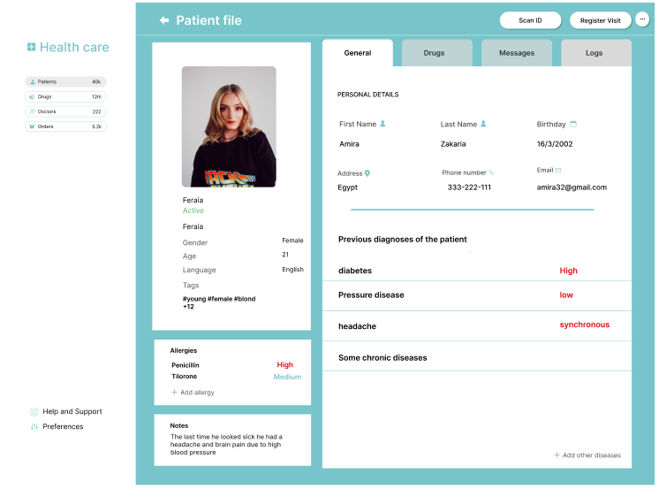7.1.1** **Patient File**

Figure2: Home page

The patient file page in a blockchain in healthcare project is crucial for several reasons, emphasizing the secure and efficient management of patient health records. Here are key points highlighting the importance of the patient file page:

Centralized Health Information:

The patient file page provides a centralized location for all patient health information, including medical history, treatment records, prescriptions, and test results. This ensures that healthcare providers have comprehensive and up-to-date information for making informed decisions.

Data Integrity and Security:

Using blockchain technology, the patient file page ensures that health records are immutable and securely stored. This prevents unauthorized alterations and enhances the trustworthiness of the medical data.

Enhanced Accessibility:

Authorized healthcare providers and patients can access the patient file from anywhere, ensuring timely and efficient access to critical health information. This is especially important in emergency situations where quick access to a patient's medical history can be lifesaving.

Interoperability:

The patient file page on a blockchain system can facilitate interoperability between different healthcare systems and providers. This enables seamless sharing of patient information across various medical facilities, improving the coordination of care.

Patient Empowerment:

Patients can have direct access to their own health records, allowing them to be more engaged and proactive in managing their health. They can also grant access to specific healthcare providers as needed, giving them control over their personal health information.

Transparency and Accountability:

Blockchain provides a transparent and tamper-proof record of all interactions with the patient file. This increases accountability among healthcare providers and ensures that all changes or accesses are logged and can be audited if necessary.

Streamlined Workflows:

By providing a comprehensive and easily accessible patient file, healthcare providers can streamline their workflows. This reduces the time spent on administrative tasks and allows more focus on patient care.

Enhanced Data Sharing:

The patient file page can facilitate secure data sharing between patients, providers, and researchers. This can accelerate medical research and improve public health outcomes by providing access to a vast amount of anonymized health data.

Improved Patient Outcomes:

With accurate, up-to-date, and readily accessible patient information, healthcare providers can deliver more effective and personalized care. This leads to improved patient outcomes and a higher quality of care.

Compliance with Regulations:

A well-designed patient file page on a blockchain platform can help ensure compliance with healthcare regulations and standards, such as HIPAA. This is achieved by providing secure, auditable, and transparent management of patient data.

In summary, the patient file page in a blockchain in healthcare project is essential for centralizing health information, ensuring data security and integrity, enhancing accessibility and interoperability, empowering patients, and improving overall healthcare outcomes.

**7.1.2** **Doctors**

**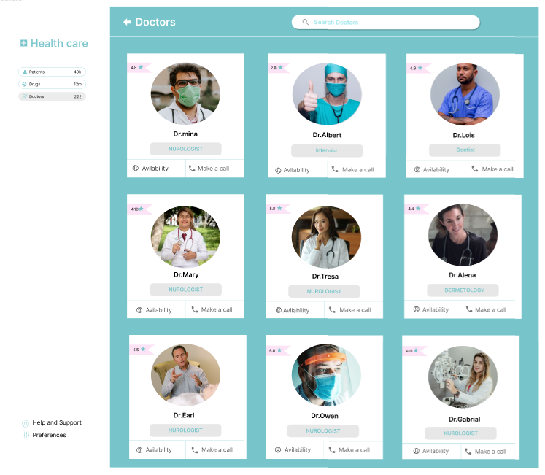**

Figure3: Doctors page

The doctors' page in a blockchain-based healthcare project holds significant importance for several reasons, primarily focusing on facilitating efficient communication, collaboration, and access to critical information for healthcare professionals. Here are key points highlighting the importance of the doctors' page:

Provider Directory:

The doctors' page serves as a comprehensive directory of healthcare providers within the network, listing details such as specialties, qualifications, contact information, and availability. This enables patients and other healthcare professionals to easily find and connect with the appropriate doctors.

Appointment Scheduling:

Integrating appointment scheduling functionality within the doctors' page streamlines the process for patients to book appointments with specific doctors. This enhances convenience for patients and optimizes the scheduling workflow for healthcare providers.

Secure Communication:

Utilizing blockchain technology, the doctors' page can facilitate secure and encrypted communication channels between healthcare providers. This allows for the exchange of sensitive patient information, treatment plans, and consultations while maintaining confidentiality and compliance with privacy regulations.

Access to Patient Records:

Doctors can access patient records securely through the blockchain network, enabling them to review medical history, lab results, medications, and other relevant information. This comprehensive view supports informed decision-making and personalized patient care.

Collaborative Care Coordination:

The doctors' page fosters collaborative care coordination by enabling healthcare providers to communicate, share insights, and collaborate on treatment plans in real-time. This interdisciplinary approach enhances patient outcomes and ensures continuity of care.

Continuing Medical Education (CME):

Integrating educational resources and CME opportunities within the doctors' page supports ongoing professional development for healthcare providers. Access to latest research, guidelines, and training materials empowers doctors to stay updated with advancements in their field.

Clinical Decision Support:

Incorporating clinical decision support tools within the doctors' page assists healthcare providers in making evidence-based decisions. This may include diagnostic support, treatment algorithms, and alerts for potential drug interactions or contraindications.

Quality Assurance and Peer Review:

The doctors' page can facilitate peer review processes and quality assurance initiatives within the healthcare network. This promotes best practices, knowledge sharing, and continuous improvement in clinical care standards.

Provider Performance Metrics:

Tracking provider performance metrics and outcomes data on the doctors' page supports accountability and transparency. This allows healthcare organizations to monitor and benchmark individual doctor performance, identify areas for improvement, and recognize excellence.

Compliance and Regulatory Requirements:

Ensuring that the doctors' page adheres to regulatory requirements and industry standards, such as HIPAA compliance, safeguards patient privacy and data security. This instills trust among patients and ensures legal compliance for healthcare organizations.

In summary, the doctors' page in a blockchain-based healthcare project plays a crucial role in facilitating efficient communication, collaboration, access to patient information, and quality care delivery.

By leveraging blockchain technology and innovative features, it enhances the overall effectiveness, transparency, and reliability of healthcare services provided by doctors within the network.

***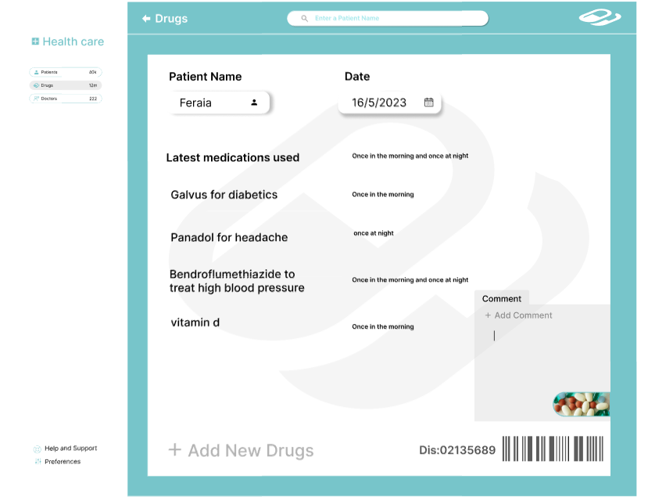*7.1.3** **Drugs**

Figure4: Drugs page

The drugs page in a blockchain-based healthcare project is of significant importance due to its role in ensuring transparency, traceability, and safety in the management of pharmaceutical products. Here are key points highlighting the importance of the drugs page:

Drug Authentication and Traceability:

The drugs page provides a transparent record of pharmaceutical products registered within the blockchain network. Each drug entry includes essential information such as the manufacturer, batch number, expiration date, and distribution history.

This enables healthcare providers and patients to verify the authenticity and trace the journey of drugs from production to consumption, thereby reducing the risk of counterfeit or substandard medications.

Medication Management:

Healthcare professionals can access comprehensive information about drugs, including dosage instructions, potential side effects, drug interactions, and contraindications. This facilitates safe prescribing practices and supports informed decision-making regarding medication management.

Supply Chain Optimization:

By leveraging blockchain technology, the drugs page enhances supply chain visibility and efficiency. It enables stakeholders, including manufacturers, distributors, pharmacies, and regulatory authorities, to monitor the movement of drugs in real-time, identify bottlenecks, and streamline logistics processes.

This helps prevent drug shortages, minimize wastage, and ensure timely access to essential medications.

Adverse Event Reporting:

Healthcare providers and patients can report adverse drug reactions or incidents directly through the drugs page. These reports are securely recorded on the blockchain, allowing for prompt investigation, risk assessment, and implementation of appropriate safety measures. This contributes to pharmacovigilance efforts and improves patient safety.

Regulatory Compliance:

The drugs page facilitates compliance with regulatory requirements and standards governing the pharmaceutical industry, such as Good Manufacturing Practices (GMP) and Drug Enforcement Administration (DEA) regulations. It ensures that drugs listed on the platform meet quality, safety, and efficacy standards mandated by regulatory authorities.

Clinical Trials and Research:

Researchers and healthcare professionals can access information about ongoing clinical trials, research studies, and drug development initiatives through the drugs page. This fosters collaboration, data sharing, and innovation in pharmaceutical research, ultimately leading to the discovery of new treatments and therapies.

Patient Education and Empowerment:

Patients can access educational resources, medication guides, and information leaflets through the drugs page. This empowers patients to make informed decisions about their healthcare, understand their prescribed medications, and adhere to treatment regimens, thereby improving medication adherence and health outcomes.

Drug Pricing and Affordability:

The drugs page may include pricing information for medications, facilitating transparency and comparison shopping for patients. It also supports efforts to address issues of drug affordability and accessibility by highlighting generic alternatives, patient assistance programs, and cost-saving opportunities.

Data Analytics and Insights:

Aggregate data collected through the drugs page can be analyzed to identify trends, patterns, and pharmacoeconomic insights.

This information can inform healthcare policies, formulary decisions, and population health management strategies, ultimately optimizing healthcare delivery and resource allocation.

In summary, the drugs page in a blockchain-based healthcare project plays a pivotal role in promoting medication safety, supply chain integrity, regulatory compliance, patient empowerment, and innovation in the pharmaceutical industry.

By leveraging blockchain technology, it enhances transparency, efficiency, and trust in the management of drugs, ultimately benefiting healthcare stakeholders and improving patient outcomes.

***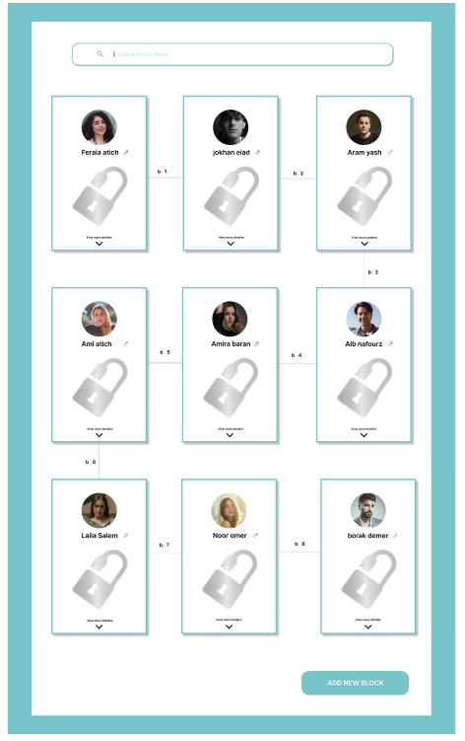*7.1.4** **Blocks**

Figure5: Blocks page

The "blocks" page in a blockchain-based healthcare project holds significant importance as it serves as the foundation for secure, transparent, and immutable record-keeping of healthcare transactions and data. Here are key points highlighting the importance of the blocks page:

Transaction Transparency:

The blocks page provides a transparent record of all transactions or data entries recorded on the blockchain network. Each block contains a cryptographic hash of the previous block, creating a sequential and tamper-evident chain of transactions. This transparency enhances trust among stakeholders and ensures the integrity of healthcare data.

Immutable Data Storage:

Once a transaction is recorded on a block and added to the blockchain, it becomes immutable and cannot be altered or deleted. This ensures the permanence and reliability of healthcare records, preventing unauthorized modifications or tampering with sensitive patient information.

Data Security and Privacy:

The blocks page utilizes cryptographic techniques to secure healthcare data and protect patient privacy. Transactions are encrypted and validated by network participants through consensus mechanisms, such as proof of work or proof of stake, ensuring that only authorized users can access and verify data stored on the blockchain.

Auditability and Compliance:

Healthcare organizations can use the blocks page to demonstrate compliance with regulatory requirements and industry standards, such as HIPAA or GDPR. The transparent and auditable nature of blockchain technology enables regulators and auditors to verify the integrity and authenticity of healthcare transactions, streamlining compliance efforts and reducing audit-related costs.

Decentralized Data Management:

By distributing copies of the blockchain ledger across multiple nodes or computers in a decentralized network, the blocks page eliminates single points of failure and minimizes the risk of data loss or manipulation. This decentralized architecture enhances the resilience and availability of healthcare data, even in the event of network disruptions or cyber attacks.

Interoperability and Data Sharing:

The blocks page facilitates interoperability and seamless data sharing between different healthcare systems, providers, and stakeholders. Healthcare transactions recorded on the blockchain can be accessed and verified by authorized parties, enabling secure and efficient exchange of patient information across organizational boundaries.

Smart Contract Execution:

In addition to storing healthcare data, the blocks page can also support the execution of smart contracts, self-executing agreements programmed to automatically trigger actions or transactions when predefined conditions are met. Smart contracts enable automated processes, such as insurance claims processing or supply chain management, enhancing efficiency and reducing administrative overhead.

Research and Analytics:

Researchers and healthcare analysts can leverage data stored on the blocks page to conduct retrospective studies, analyze trends, and derive insights into population health, disease prevalence, and treatment outcomes. This data-driven approach to healthcare research enables evidence-based decision-making and continuous improvement in healthcare delivery.

In summary, the blocks page in a blockchain-based healthcare project serves as the backbone of secure, transparent, and interoperable data management. By leveraging blockchain technology, it ensures data integrity, privacy, and auditability, while also facilitating decentralized collaboration, smart contract execution, and data-driven research in the healthcare industry.

**7.1.5** **Add Block.**

**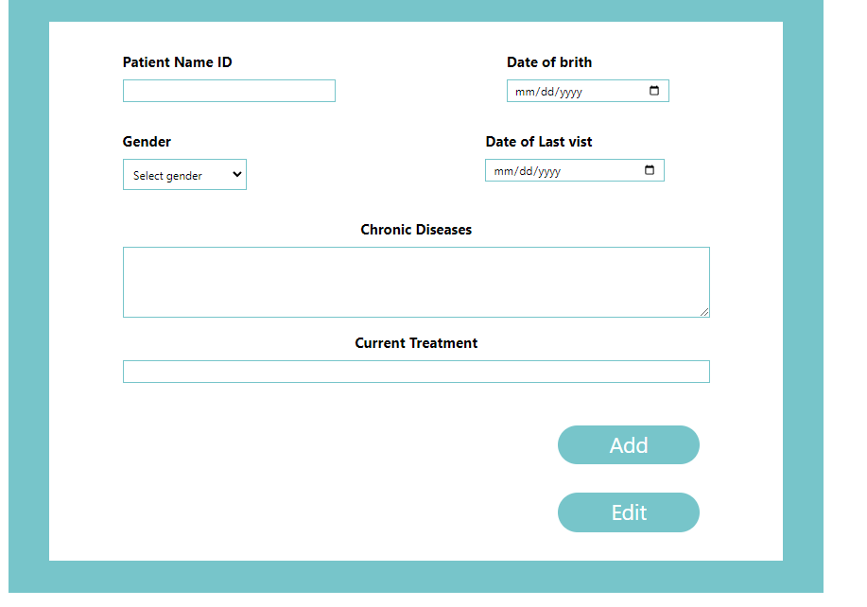**

Figure6: Add Block page

The "add block" page in a blockchain-based healthcare project serves as a crucial gateway for appending new data or transactions onto the blockchain ledger.

Here are key points highlighting its importance:

Secure Data Addition:

The add block page provides a secure mechanism for adding new data or transactions to the blockchain. This ensures that only authorized parties can append information, maintaining the integrity and security of the healthcare records.

Immutable Record-Keeping:

By adding data to the blockchain through the add block page, healthcare transactions become immutable and tamper-proof. Once recorded, the information cannot be altered or deleted, providing a reliable audit trail of all activities.

Data Traceability:

New data appended through the add block page becomes part of a transparent and traceable chain of blocks. This allows stakeholders to trace the history of healthcare transactions back to their origin, enhancing accountability and transparency.

Real-Time Updates:

Healthcare data often needs to be updated in real-time to reflect changes in patient conditions, treatments, or prescriptions. The add block page enables immediate updates to the blockchain, ensuring that healthcare providers have access to the most current information.

Interoperability:

The add block page facilitates interoperability by allowing healthcare data to be added to the blockchain in a standardized format.

This promotes seamless data exchange between different healthcare systems, improving care coordination and continuity.

Compliance with Regulations:

Adding data to the blockchain through the add block page helps healthcare organizations comply with regulatory requirements such as HIPAA or GDPR. The transparent and secure nature of blockchain technology ensures that patient data is handled in accordance with privacy laws.

Enhanced Security:

The add block page employs cryptographic techniques to ensure the security and authenticity of data added to the blockchain.

Transactions are validated by network participants through consensus mechanisms, reducing the risk of fraud or unauthorized access.

Patient Empowerment:

Patients can benefit from the add block page by having control over their own health data. They can grant permission for specific healthcare providers to add data to the blockchain, empowering them to manage their healthcare information securely.

Efficient Data Management:

The add block page streamlines data management processes by providing a centralized platform for adding new information to the blockchain.

This reduces administrative overhead and improves the efficiency of healthcare operations. In summary, the add block page plays a pivotal role in ensuring the integrity, security, and transparency of healthcare data within a blockchain-based system. It enables secure data addition, maintains immutable records, supports real-time updates, and promotes interoperability while ensuring compliance with regulatory requirements.

**7.1.6** **Edit Blocks.**

****

Figure7: Edit Blocks page

The "edit" page in a blockchain-based healthcare project holds significant importance as it allows authorized users to update or modify relevant information within the system. Here are key points highlighting the importance of the edit page:

Data Accuracy and Integrity:

The edit page enables healthcare professionals or administrators to ensure that patient information, treatment plans, or other relevant data are accurate and up-to-date. Maintaining data accuracy is crucial for providing quality care and making informed decisions.

Timely Updates:

Healthcare records may need to be updated regularly to reflect changes in a patient's condition, treatment regimen, or personal information. The edit page facilitates timely updates, ensuring that healthcare providers have access to the most current information when delivering care.

Adaptation to Changing Needs:

The healthcare landscape is constantly evolving, and the edit page allows for adjustments to be made to accommodate changing regulatory requirements, clinical guidelines, or organizational policies. This flexibility ensures that the system remains compliant and aligned with best practices.

Patient Engagement and Empowerment:

Empowering patients to participate in the management of their own health information is essential. The edit page can provide patients with the ability to update personal details, medical history, or preferences, fostering a sense of ownership and involvement in their healthcare journey.

Enhanced Communication and Collaboration:

Updating information through the edit page facilitates communication and collaboration among healthcare providers. For example, a physician may update a patient's treatment plan, which can then be accessed and reviewed by other members of the care team, promoting coordinated care delivery.

Audit Trail and Accountability:

Changes made through the edit page are recorded on the blockchain, creating an immutable audit trail of modifications. This enhances accountability by providing a transparent record of who made the changes, when they were made, and the rationale behind them.

Streamlined Workflows:

Efficient workflows are essential for optimizing healthcare delivery. The edit page streamlines administrative processes by allowing for quick and seamless updates to patient records or administrative tasks, reducing redundant data entry and minimizing errors.

Privacy and Security:

Access controls and encryption mechanisms can be implemented to ensure that only authorized users have the ability to edit or modify sensitive healthcare data. This helps maintain patient privacy and protects against unauthorized access or tampering.

Compliance with Regulations:

Ensuring that edits to healthcare records comply with regulatory requirements, such as HIPAA or GDPR, is critical for maintaining data privacy and security. The edit page can incorporate features to enforce compliance with relevant laws and standards. In summary, the edit page in a blockchain-based healthcare project plays a vital role in maintaining data accuracy, facilitating timely updates, empowering patients, supporting collaboration among healthcare providers, ensuring accountability, and enhancing overall efficiency and effectiveness in healthcare delivery.

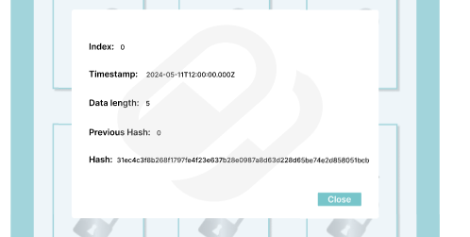7.1.7 Blocks Information**.**

Figure8: Blocks Information page

Figure 8

**7.2** **Back end Blockchain**

**7.2.1 Node.js**

Node.js is an open-source, cross-platform JavaScript runtime environment that allows developers to execute JavaScript code outside of a web browser. It is built on Chrome's V8 JavaScript engine and enables the development of scalable and high-performance network applications. Here is a brief overview:

**Key Features of Node.js**

1. **Asynchronous and Event-Driven**:
   * Node.js operates on a single-threaded event loop, which enables it to handle multiple connections concurrently without creating multiple threads for each connection. This non-blocking I/O model makes it efficient and lightweight.
2. **Fast Execution**:
   * Built on the V8 engine, Node.js compiles JavaScript directly into machine code, allowing for fast execution of code.
3. NPM (Node Package Manager):
   * Node.js comes with NPM, a robust package manager that hosts thousands of libraries and modules. This allows developers to easily include and manage dependencies in their projects.
4. Cross-Platform:
   * Node.js can be run on various operating systems including Windows, Linux, and macOS, making it versatile and adaptable to different environments.
5. Scalability:
   * Designed with scalability in mind, Node.js can handle numerous simultaneous connections with high throughput. It is particularly suited for I/O-bound applications such as web servers and real-time applications.

Common Use Cases

1. Web Servers:
   * Node.js is often used to create server-side applications. It can handle HTTP requests and build web servers that serve dynamic content.
2. APIs:
   * Creating RESTful APIs and GraphQL APIs is straightforward with Node.js, thanks to its asynchronous nature and extensive ecosystem.
3. Real-Time Applications:
   * Ideal for applications that require real-time interaction, such as chat applications, online gaming, and live streaming.
4. Microservices:
   * Node.js is a good choice for building microservices due to its lightweight nature and support for handling multiple connections concurrently.

Core Modules

Node.js comes with several built-in modules that provide basic functionalities:

* HTTP: To create HTTP servers and handle client requests.
* File System (fs): To interact with the file system for reading and writing files.
* Path: To handle and transform file paths.
* URL: To parse and format URL strings.
* Crypto: To handle encryption and decryption tasks.

**7.2.1 SQLite**

SQLite is a software library that provides a relational database management system (RDBMS). Unlike other RDBMSs like MySQL or PostgreSQL, SQLite is not a standalone database server. Instead, it is embedded within the application that uses it. Here’s a detailed breakdown of what SQLite does and how it functions:

Key Features and Characteristics

1. Self-contained:
   * SQLite is a complete database system that is contained within a single library, requiring no additional components.
2. Serverless:
   * SQLite does not have a separate server process. The database engine is part of the application, which directly reads and writes to the database file.
3. Zero-configuration:
   * There is no setup or administration required. SQLite does not need to be installed and configured separately. It creates and manages database files automatically.
4. Transactional:
   * SQLite uses transactions to ensure that changes to the database are atomic, consistent, isolated, and durable (ACID properties). This means that either all operations of a transaction are completed successfully, or none of them are applied.
5. Cross-platform:
   * SQLite can be used on various platforms including Windows, macOS, Linux, iOS, and Android.
6. Lightweight:
   * It is designed to be compact, with the library size often being less than 1 MB, making it suitable for mobile and embedded systems.

How SQLite Works

1. Database File:
   * SQLite stores the entire database, including tables, indexes, and the data itself, in a single cross-platform disk file.
2. SQL Interface:
   * SQLite supports most of the SQL-92 standard for database querying and manipulation. You can create tables, insert data, update records, and perform complex queries using SQL statements.
3. Data Types:
   * SQLite uses dynamic typing. This means that values are not bound to a specific type, and types are assigned to values rather than to columns.
4. Architecture:
   * When an application makes a query, SQLite translates that SQL query into a series of operations. It then reads from or writes to the database file as needed. This is done efficiently to minimize disk I/O.
5. Concurrency:
   * SQLite handles multiple readers and a single writer at a time. It uses database-level locking to manage access, ensuring data integrity.
6. Backup and Recovery:
   * SQLite includes features for creating backups and recovering from database corruption. It supports online backup operations to copy the database file while it is still in use.

Use Cases

* Embedded Systems: Ideal for applications that need a simple, lightweight database without the overhead of a full database server.
* Mobile Applications: Commonly used in mobile apps for storing user data, app settings, and offline content.
* Desktop Applications: Suitable for small to medium-sized applications that need a local database.
* Web Browsers: Used for storing client-side data in web applications.
* Test Databases: Frequently used in development and testing environments due to its simplicity and ease of setup.

**7.2.1** **blockchain.js.**

The provided JavaScript code defines a simple implementation of a blockchain. It consists of two classes, Block and Blockchain, that together allow for the creation and verification of a chain of blocks. Below is a detailed explanation of each part of the code:

* Block Class

The Block class represents a single block in the blockchain.

* Constructor

The constructor initializes the block with several properties:

'index': A numerical index representing the block's position in the blockchain.

'timestamp': The time at which the block was created.

'data': Any data that the block is supposed to store.

'previousHash': The hash of the previous block in the chain, defaulting to an empty string if not provided.

'entityType': An optional string representing the type of entity (default is an empty string).

hash: The hash of the current block, calculated using the calculateHash method.

**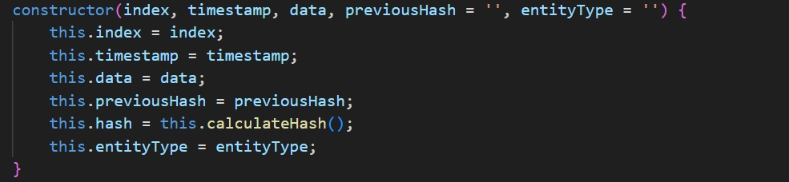**

Figure 9

* **CalculateHash Method**

This method computes a SHA-256 hash of the block's contents. It concatenates the block's properties into a single string, which is then hashed.



Figure 10

**Blockchain Class**

The Blockchain class manages a chain of blocks.

* **Constructor**

The constructor initializes the blockchain with a single block, the genesis block.

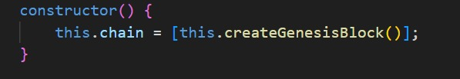

Figure 11

* **CreateGenesisBlock Method**

This method creates the first block in the blockchain, often referred to as the genesis block. It has a fixed index of 0, the current timestamp, a specific data string ('Genesis Block'), and a previous hash of '0'.

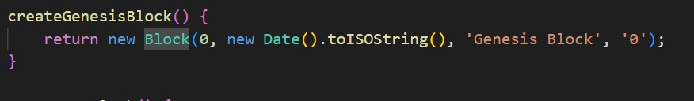

Figure 12

* GetLatestBlock Method

This method returns the most recent block in the blockchain.

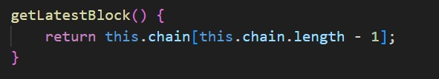

Figure 13

* **AddBlock Method**

This method adds a new block to the blockchain. It first sets the previousHash of the new block to the hash of the latest block in the chain. Then, it recalculates the new block's hash and adds it to the chain.

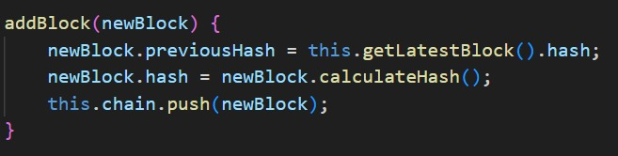

Figure 14

* **IsChainValid Method**

This method verifies the integrity of the blockchain. It iterates through each block, starting from the second block, and checks:

1. If the current block's hash matches its calculated hash.
2. If the previousHash of the current block matches the hash of the previous block.

If any of these conditions fail, the blockchain is considered invalid.

**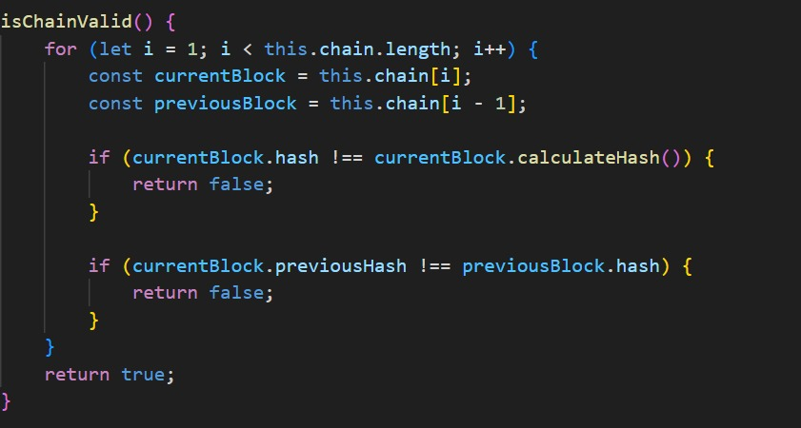**

Figure 15

* **Module Exports**

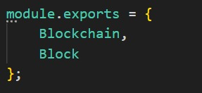Finally, the code exports the Blockchain and Block classes, making them available for import in other files.

Figure 16

**7.2.2** **server.js.**

This JavaScript code sets up a web server using Express.js to manage healthcare data (patients, doctors, and drugs) stored in a SQLite database and integrates blockchain functionality to log changes. Below is a detailed explanation of each section of the code:

**Module Imports and Initialization**

**1-Imports:**

* 'express': A web framework for creating the server.
* 'body-parser': Middleware to parse incoming JSON request bodies.
* ' sqlite3': SQLite database library.
* ' { Blockchain, Block }': Custom modules for blockchain functionality from a local file .'/blockchain'.

**2-Initialization:**

* ' app': An instance of the Express application.
* 'port': The port number for the server to listen on (3000).
* 'body-parser': Configured to parse JSON payloads.

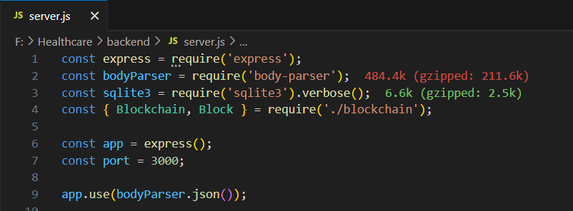

Figure 17

**3-Database Connections:**

* Creating connections to SQLite databases for patients, doctors, and drugs.



Figure 18

**4-Blockchain Initialization:**

* 'healthcareChain': An instance of the Blockchain class to store and manage the blockchain.



Figure 19

**Helper Function**

**5- Add Block to Blockchain:**

* Function to add a new block to the blockchain, storing entity data (patients, doctors, drugs).

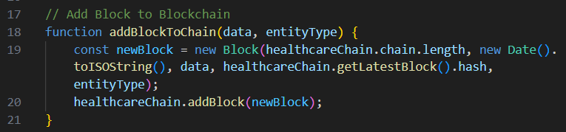

Figure 20

**Patients Routes**

**6-Get Patient Blocks:**

* Endpoint to retrieve all patient-related blocks from the blockchain.

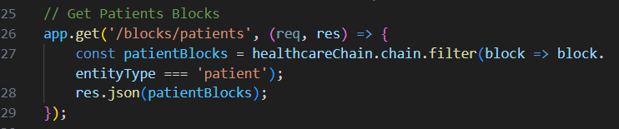

Figure 21

**7-Add Patient:**

* Endpoint to add a new patient to the database and log this in the blockchain.

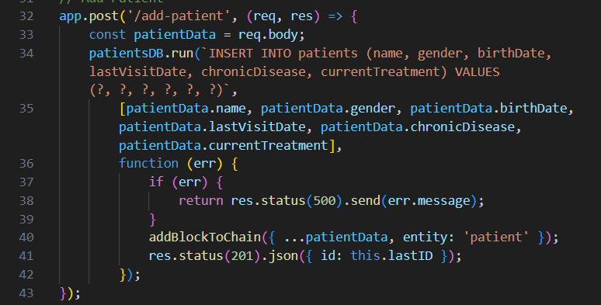

# 

Figure 21

**8-Get Patient Data:**

* Endpoint to retrieve a specific patient's data by ID.

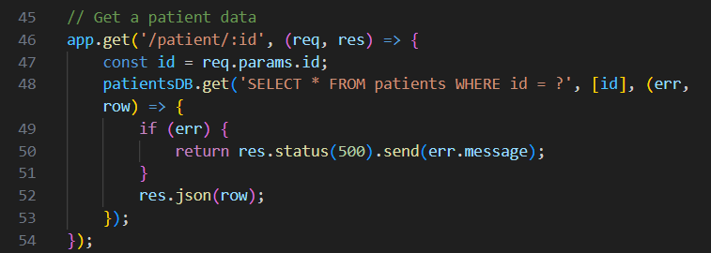

Figure 22

**9-Update Patient:**

* 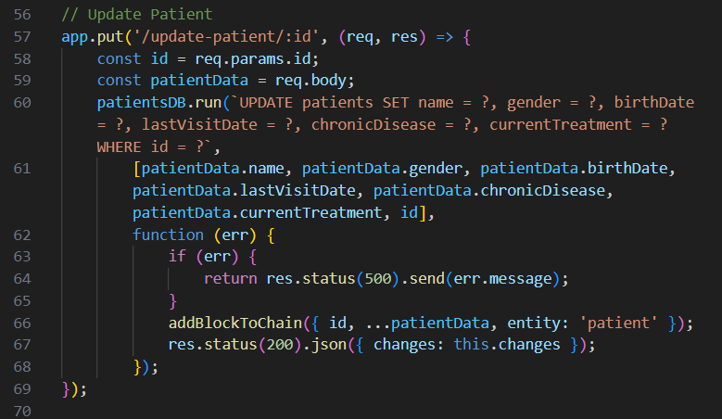Endpoint to update a specific patient's data and log this update in the blockchain.

Figure 23

**10-Delete Patient:**

* 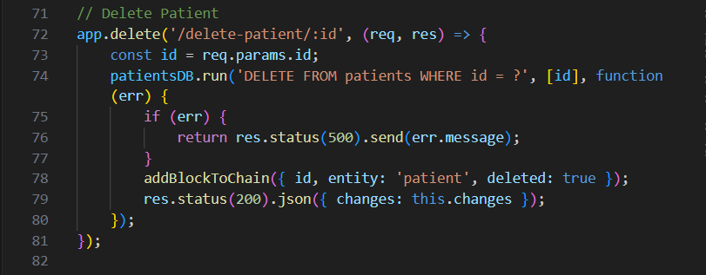Endpoint to delete a patient's data and log this deletion in the blockchain.

Figure 24

**11-Get Doctor Blocks:**

* **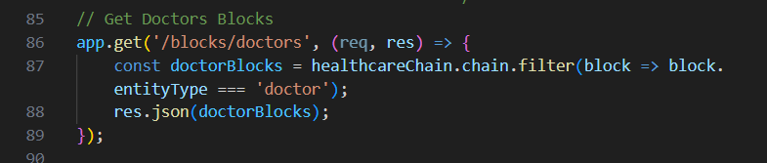**Endpoint to retrieve all doctor-related blocks from the blockchain.

Figure 25

**12-Add Doctor:**

* 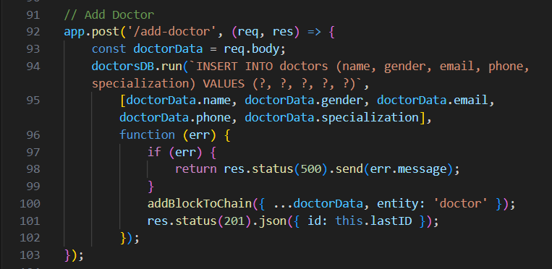Endpoint to add a new doctor to the database and log this in the blockchain.

Figure 26

**13-Get Doctor Data:**

* **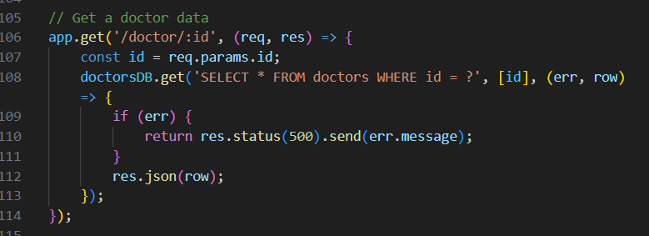**Endpoint to retrieve a specific doctor's data by ID.

Figure 27

**14-Update Doctor:**

* **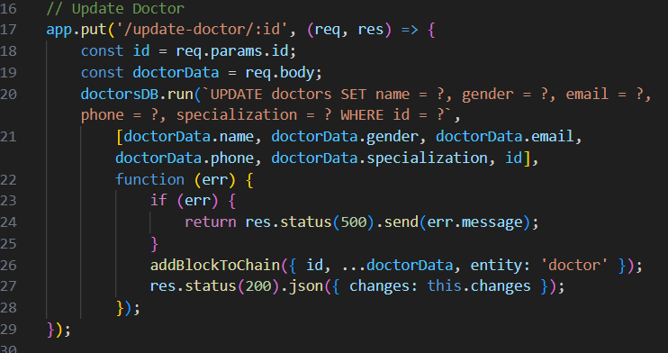**Endpoint to update a specific doctor's data and log this update in the blockchain.

Figure 28

**15-Delete Doctor:**

* 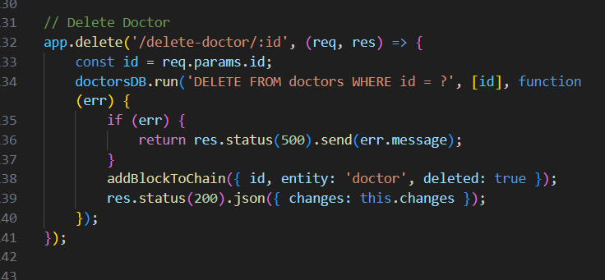Endpoint to delete a doctor's data and log this deletion in the blockchain.

Figure 29

**Drugs Routes**

**16-Get Drug Blocks:**

* 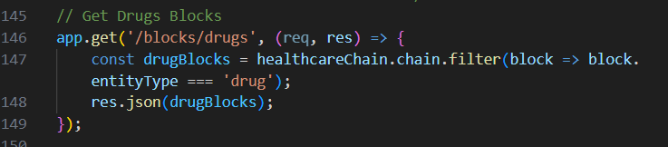Endpoint to retrieve all drug-related blocks from the blockchain.

Figure 30

**17-Add Drug:**

* 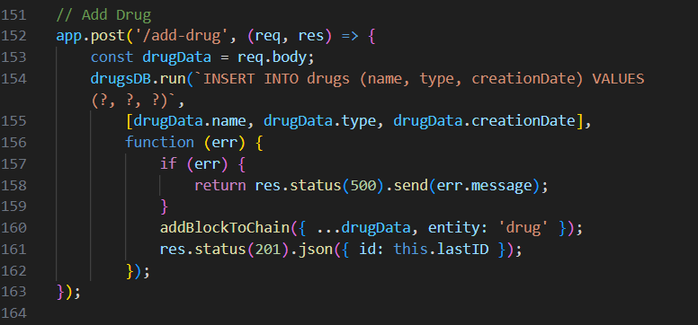Endpoint to add a new drug to the database and log this in the blockchain.

Figure 31

**18-Get Drug Data:**

* Endpoint to retrieve a specific drug's data by ID.

Figure 32

**19-Update Drug:**

* 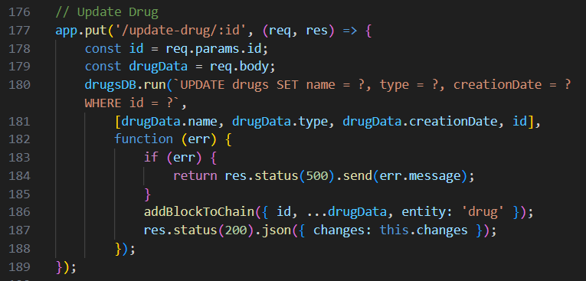Endpoint to update a specific drug's data and log this update in the blockchain.

Figure 33

**20-Delete Drug:**

* 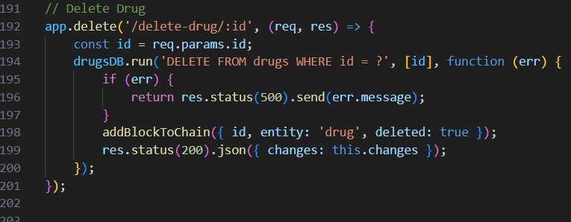Endpoint to delete a drug's data and log this deletion in the blockchain.

Figure 34

**Server Start**

**21-Start the Server:**

* 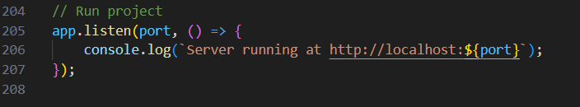The server starts listening on the specified port (3000) and logs a message when it is running.

Figure 35

This code provides a RESTful API for managing healthcare data while maintaining an immutable record of changes using a blockchain. Each entity (patients, doctors, drugs) has CRUD (Create, Read, Update, Delete) operations, and the blockchain logs each change to ensure data integrity and traceability.

# **8.****Courses**

Blockchain 101 Tutorial (Source from YouTube)[21].

Node.js (Source from YouTube).

Building a blockchain with Javascript (Source from YouTube).

LocalStorage & Application (Source from YouTube).

# 

# **9.** **Technologies Used**

**9.1. Visual Studio Code:-**

the program that we used in building the project and specified it in building the front-end, back-end, and blockchain.

**9.2. Node.js :-**

is a runtime environment based on Google Chrome's V8 engine that allows you to run JavaScript on the backend (server) instead of in the browser.

Uses: Developing web applications and servers, building web services, and real-time applications such as chat and online games.

Express.js:-

Express.js is a simple web framework built on Node.js that helps build web applications and APIs easily.

Uses: Development of small and large web applications, building application programming interfaces (APIs), applications based on microservices (microservices).

Advantages:

Easy to learn and use, with a wide range of functions.

Provides ways to create

Figma:-

is a cloud-based tool used for user interface and user experience.

# **10.** **Future work**

Future work in applying blockchain technology in healthcare may include several areas, such as:

**1. Secure and Interoperable Health Records:**

* Use blockchain to store patient data securely and immutably, ensuring data integrity and privacy.
* Leverage AI algorithms to analyze this blockchain-based health data to identify patterns, predict medical conditions, and provide personalized treatment recommendations.
* Implement smart contracts on the blockchain to automate data sharing and access control based on patient consent.

1. **Pharmaceutical Supply Chain Management:**

* Utilize blockchain to create a transparent, auditable record of the entire pharmaceutical supply chain from manufacturer to patient.
* Apply AI-powered analytics to optimize inventory management, predict demand, and detect counterfeit drugs.
* Automate supply chain processes like order fulfillment and payments using blockchain-based smart contracts.

1. **Clinical Trials and Drug Development:**

* Store clinical trial data securely on the blockchain to ensure integrity and transparency.
* Leverage AI to analyze large datasets from clinical trials, identify promising drug candidates, and predict patient outcomes.
* Use smart contracts on the blockchain to automate participant recruitment, consent management, and data sharing during trials.

1. **Diagnostic and Treatment Support:**

* Integrate AI-powered diagnostic tools that can analyze medical images, lab results, and patient data stored on the blockchain.
* Develop AI algorithms that provide treatment recommendations based on the patient's blockchain-based health records and clinical data.
* Utilize blockchain to securely share AI-generated insights and treatment plans with healthcare providers and patients.

1. **Remote Patient Monitoring and Telemedicine:**

* Store data from remote monitoring devices and telemedicine sessions on the blockchain to ensure data integrity and patient privacy.
* Leverage AI to analyze real-time patient data, detect anomalies, and alert healthcare providers proactively.
* Implement blockchain-based smart contracts to automate the verification and settlement of telemedicine claims.

1. **Precision Medicine and Genomic Data:**

* Use the blockchain to securely store and manage patients' genomic data, ensuring privacy and data ownership.
* Apply AI algorithms to analyze genomic data and identify genetic markers associated with specific diseases, enabling more targeted treatments.
* Develop blockchain-based platforms that allow patients to control the use of their genomic data for research and clinical applications.

# 

# **11.** **Conclusion**

Blockchain technology represents a transformative innovation in the healthcare sector, offering significant advancements. The following are the best significant advancements:

* **Improved Data Security:** Blockchain provides a decentralized system for storing data, making it difficult to hack or manipulate, thus enhancing the security of medical records and sensitive information.
* **Increased Data Transparency**: Blockchain ensures that all transactions and records are easily traceable and verifiable, reducing fraud and errors.
* **Enhanced Patient Privacy:** With strong encryption, blockchain protects patient privacy and ensures that medical data is accessible only to authorized individuals. Facilitated Data Exchange: Blockchain can improve the exchange of information between different healthcare providers, leading to better coordination and patient care, especially in emergencies or when patients move between facilities.
* **Reduced Operational Costs:** By reducing the need for intermediaries and automating administrative processes, blockchain can lower operational costs in healthcare.

Supply Chain Tracking: Blockchain can be used to track the medical supply chain, ensuring that medications and medical supplies reach the intended recipients without delays or counterfeiting.

* **Enabling Medical Research:** By providing secure and anonymized health data, blockchain can facilitate access to the necessary data for medical research without compromising patient privacy.

These benefits highlight blockchain's potential to significantly transform the healthcare sector, although overcoming regulatory, technical, and organizational challenges is essential for successful implementation.

# **12.** **References:**

1. Agbo, C. C., Mahmoud, Q., & Eklund, J. M. (2019). Blockchain Technology in Healthcare: A Systematic Review. Healthcare, 7, 33-56.  
<https://doi.org/10.3390/healthcare7020056>

2. Al-Saqaf, W., & Seidler, N. (2017). Blockchain Technology for Social Impact: Opportunities and Challenges Ahead. Journal of Cyber Policy, 2, 338-354.  
<https://doi.org/10.1080/23738871.2017.1400084>

3. Benchoufi, M., & Ravaud, P. (2017). Blockchain Technology for Improving Clinical Research Quality. Trials, 18, 3-35. <https://doi.org/10.1186/s13063-017-2035-z>

4. Zhang, P., Walker, M. A., White, J., Schmidt, D. C., & Lenz, G. (2017). Metrics for Assessing Blockchain-Based Healthcare Decentralized Apps. 2017 IEEE 19th International Conference on e-Health Networking, Applications and Services (Healthcom), Vol. 1, 1-8.  
<https://doi.org/10.1109/HealthCom.2017.8210842>

5. Siyal, A. A., Junejo, A. Z., Zawish, M., Ahmed, K., Khalil, A., & Soursou, G. (2019). Applications of Blockchain Technology in Medicine and Healthcare: Challenges and Future Perspectives. Cryptography, 3, 3.  
<https://doi.org/10.3390/cryptography3010003>

6. Kellermann, A. L., & Jones, S. S. (2013). What It Will Take to Achieve the As-Yet-Unfulfilled Promises of Health Information Technology. Health Affairs, 32, 63-68.  
<https://doi.org/10.1377/hlthaff.2012.0693>

7. Jones, S. S., Rudin, R. S., Perry, T., & Shekelle, P. G. (2014). Health Information Technology: An Updated Systematic Review with a Focus on Meaningful Use. Annals of Internal Medicine, 160, 48-54.  
<https://doi.org/10.7326/M13-1531>

8. Hölbl, M., Kompara, M., Kamišalić, A., & Zlatolas, L. N. (2018). A Systematic Review of the Use of Blockchain in Healthcare. Symmetry, 10, 470.  
<https://doi.org/10.3390/sym10100470>

9. Dimitrov, D. V. (2019). Blockchain Applications for Healthcare Data Management. Healthcare Informatics Research, 25, 51-56.  
<https://doi.org/10.4258/hir.2019.25.1.51>

10. Cyran, M. A. (2018). Blockchain as a Foundation for Sharing Healthcare Data. Blockchain in Healthcare Today, 1, 1-6.

<https://doi.org/10.30953/bhty.v1.13>

11. The Monero Project. [(accessed on 12 March 2019)]; Available online: <https://getmonero.org/the-monero-project/>

12. Dash Official Website|Dash Crypto Currency—Dash. [(accessed on 12 March 2019)]; Available online: <https://www.dash.org/>

13. Litecoin—Open Source P2P Digital Currency. [(accessed on 12 March 2019)]; Available online: <https://litecoin.org/>

14. NEO Smart Economy 2018. [(accessed on 12 March 2019)]; Available online: <https://neo.org/>

15. Qtum. [(accessed on 12 March 2019)];2018 Available online: <https://qtum.org/en>

16.  MccCarthy J. MedStar Attack Found to Be Ransomware, Hackers Demand Bitcoin. [(accessed on 12 March 2019)];2016 Available online: <https://www.healthcareitnews.com/news/medstar-attack-found-be-ransomware-hackers-demand-bitcoin>

17.Patients and Privacy: GDPR Compliance for Healthcare Organizations—Security News—Trend Micro DK. [(accessed on 12 March 2019)]; Available online: <https://www.trendmicro.com/vinfo/dk/security/news/online-privacy/patients-and-privacy-gdpr-compliance-for-healthcare-organizations>

18. Burniske C., Vaughn E., Cahana A., Shelton J. How Blockchain Technology Can Enhance Electronic Health Record Operability. Ark Invest; New York, NY, USA: 2016. [[Google Scholar](https://scholar.google.com/scholar_lookup?title=How+Blockchain+Technology+Can+Enhance+Electronic+Health+Record+Operability&author=C.+Burniske&author=E.+Vaughn&author=A.+Cahana&author=J.+Shelton&publication_year=2016&)].

19. Jovanovic B., Rousseau P.L. Handbook of Economic Growth. Elsevier; New York, NY, USA: 2005. General Purpose Technologies. [[CrossRef](https://doi.org/10.1016%2FS1574-0684(05)01018-X" \t "_blank)] [[Google Scholar](https://scholar.google.com/scholar_lookup?title=Handbook+of+Economic+Growth&author=B.+Jovanovic&author=P.L.+Rousseau&publication_year=2005&)]

20. Engelhardt M.A. Hitching Healthcare to the Chain: An Introduction to Blockchain Technology in the Healthcare Sector. Technol. Innov. Manag. Rev. 2017;7:22–34. doi: 10.22215/timreview/1111. [[CrossRef](https://doi.org/10.22215%2Ftimreview%2F1111" \t "_blank)] [[Google Scholar](https://scholar.google.com/scholar_lookup?journal=Technol.+Innov.+Manag.+Rev.&title=Hitching+Healthcare+to+the+Chain:+An+Introduction+to+Blockchain+Technology+in+the+Healthcare+Sector&author=M.A.+Engelhardt&volume=7&publication_year=2017&pages=22-34&doi=10.22215/timreview/1111&)]